**Python and Django Internship Report**

**Personal Details**

Name : Darsh Shah

College Name : L.J. Institute of Engineering and Technology

Degree : BE

Semester : 7

Github URL: https://github.com/darsh-17/Darsh-Shah-AkashT-Python

**Company Details**

Company Name : Akash Technolabs

External Guide : Akash Padhiyar

Training Duration : 26-05-2021 to 21-06-2021

**Index**

|  |  |  |
| --- | --- | --- |
| **Index** | **Task Detail** | **Page Name** |
| 1 | Overview of Python | 3 |
| 2 | Comments, variables and Data Structures in Python | **3** |
| **3** |  |  |
|  |  |  |
|  |  |  |
|  |  |  |
|  |  |  |
|  |  |  |
|  |  |  |
|  |  |  |
|  |  |  |

Day-1: Today was the first day of our internship. It started with the introduction of Akash Sir who is the CEO of Akash Technolabs. Then we had a doubt session where various fellow interns asked their doubts to sir. Then our training began with Introduction to basics of Python. First we were introduced to various editors and IDE where we can write and execute our Python codes. Then we were introduced to print statement which is used to print various elements. As this was our first day so nothing much on coding part was done.

Day-2: Today was Day-2 of our Python and Django Internship. First we were introduced to comments in Python. How can we make single line and double line comments, what are the various uses of comments etc.. Then we were taught how can we declare and assign values to variables. How can we assign same value to different variables and how can we assign different values to different variables using a single line of code. Then we were introduced to different data types of Python such as String, Tuple, List, Dictionary and various operations that can be applied to them such as slicing and dicing.

This is the screenshot of the code and its output of what was taught on day-2

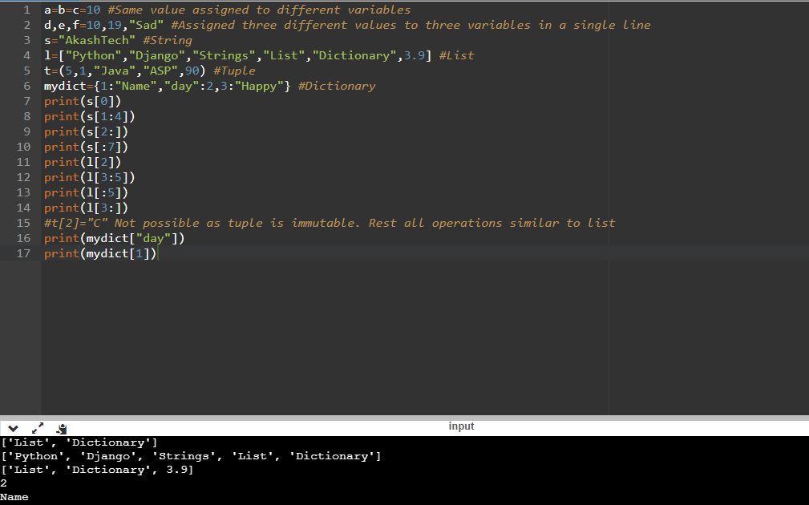

Day-3: On the Day-3 of our Python and Django Internship, we were introduced to conditional statements and loops in Python. Conditional statements included IF....ELSE statements, nested IF....ELSE statements, IF...ELIF statements. Then we were taught various types of loops such as for loop and while loop. Then we were introduced to range() function with one argument, two arguments and three arguments. Then we were introduced to break, continue and pass statements and their importance in loops.

Daily Task: We were given to solve 15 programs. The link of the pdf containing screenshots is put below.

**1)**

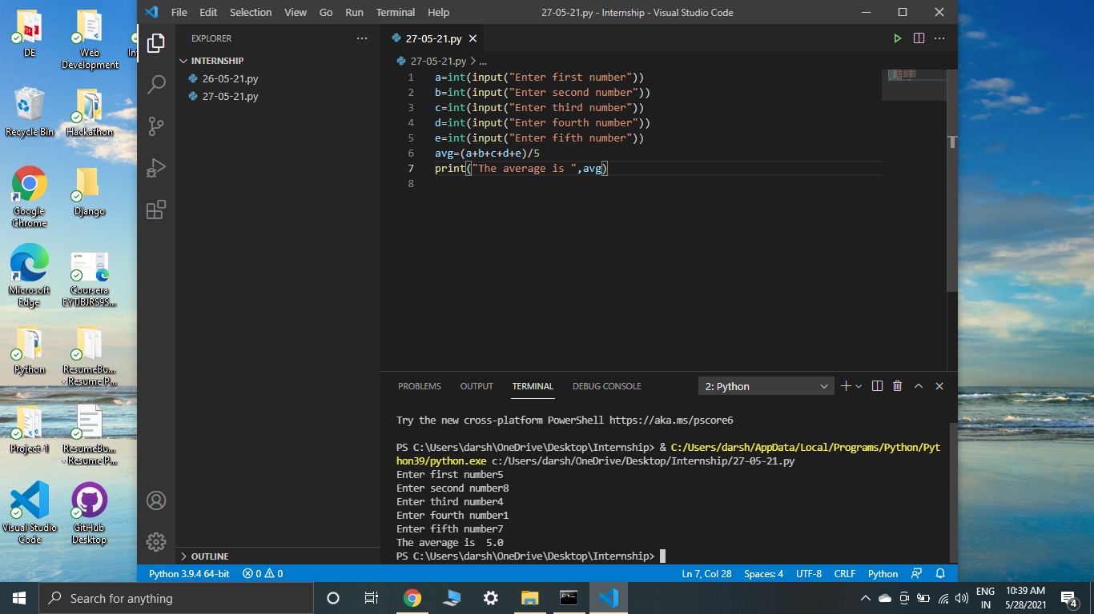

**2)**

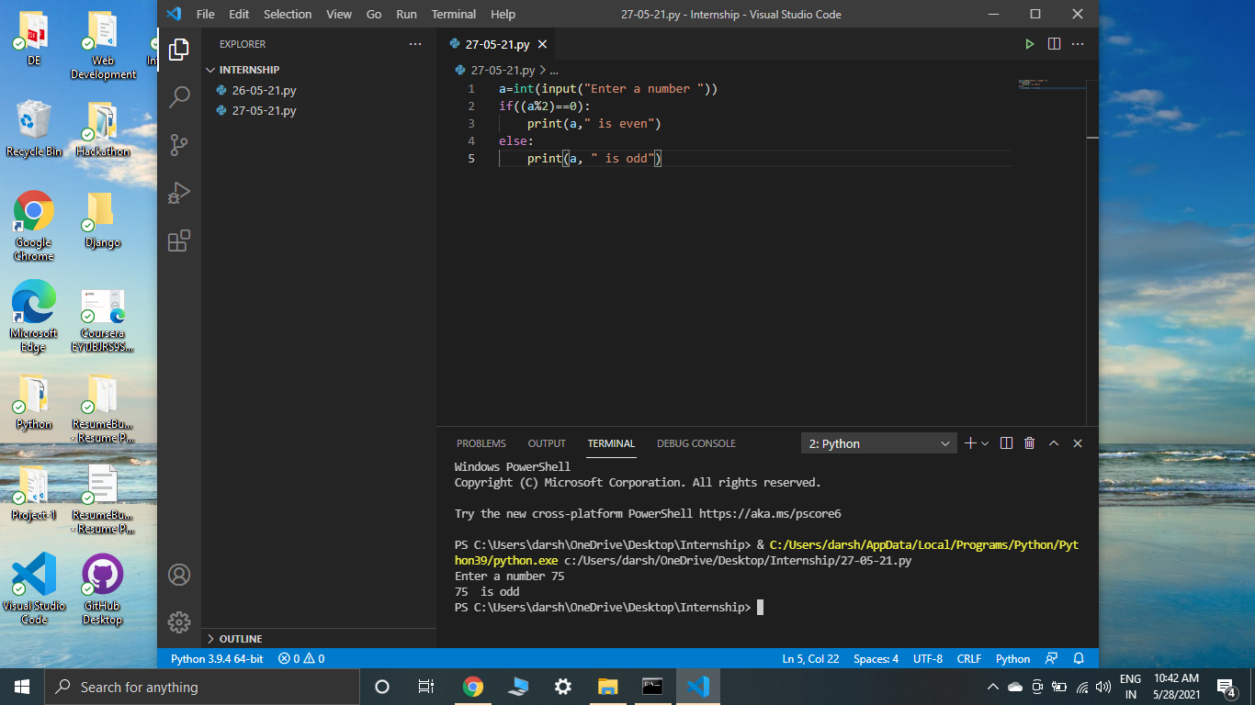

**3)**

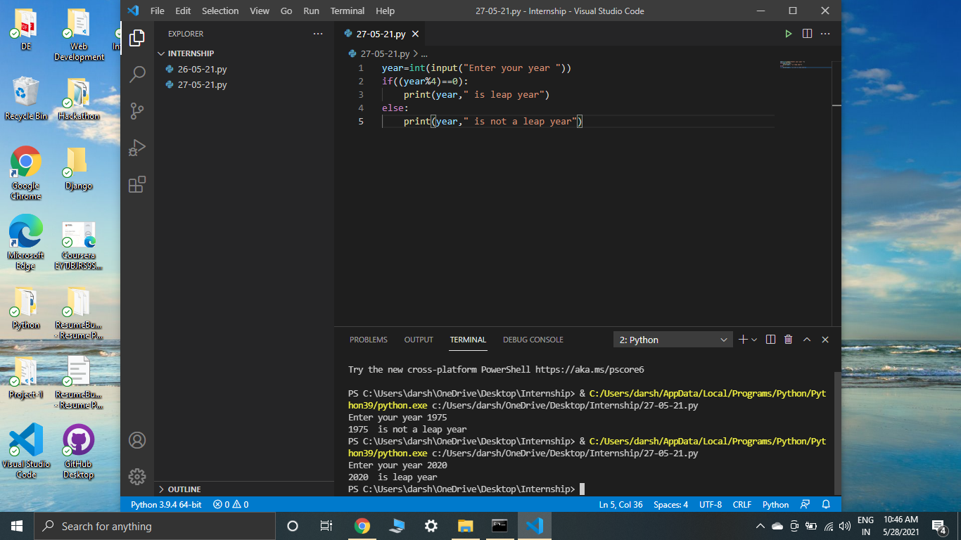

**4)**

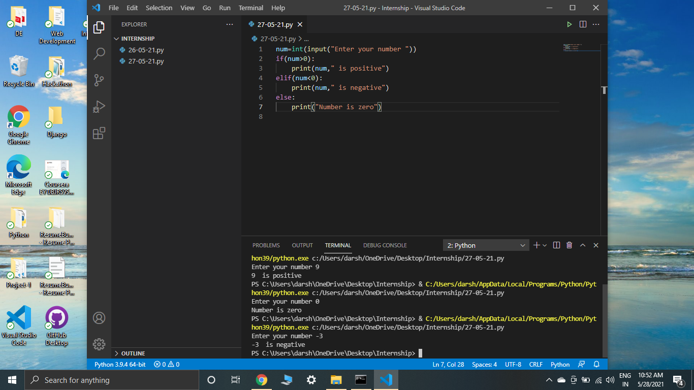

**5)**

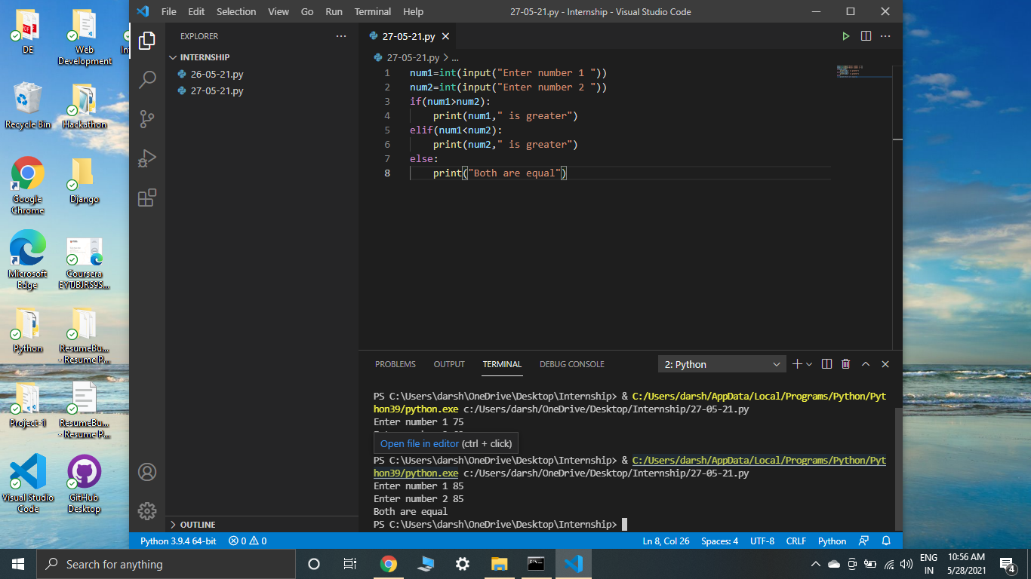

**6)**

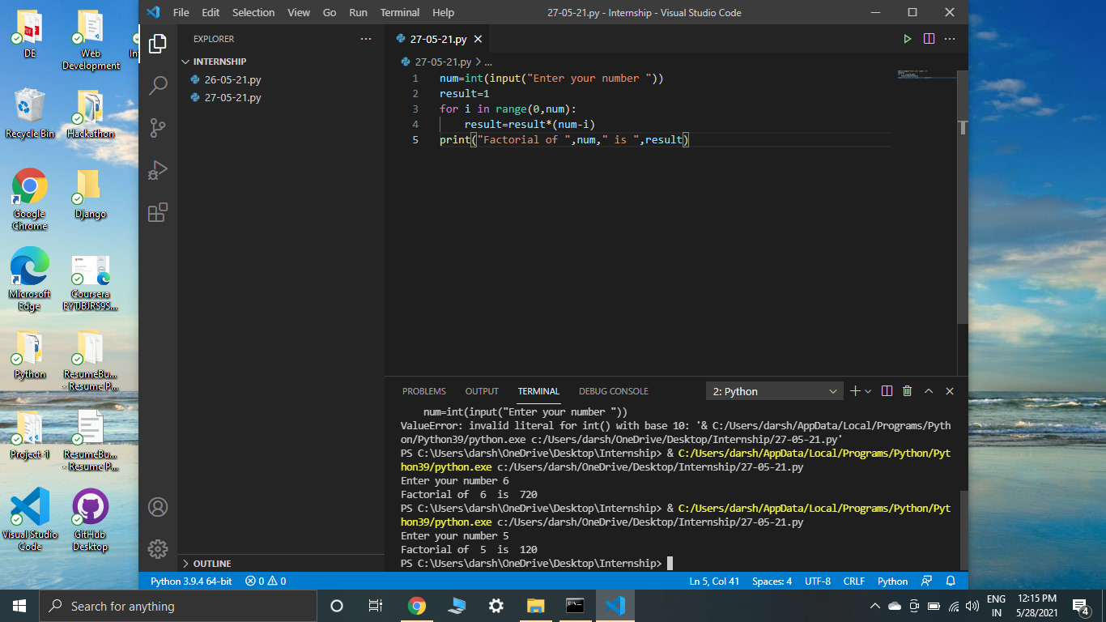

**7)**

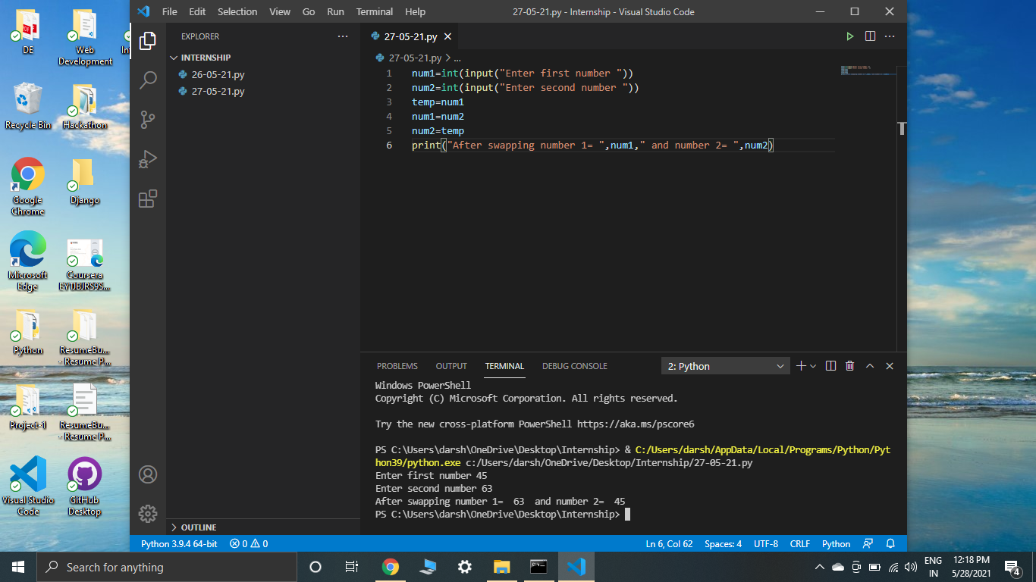

**8)**

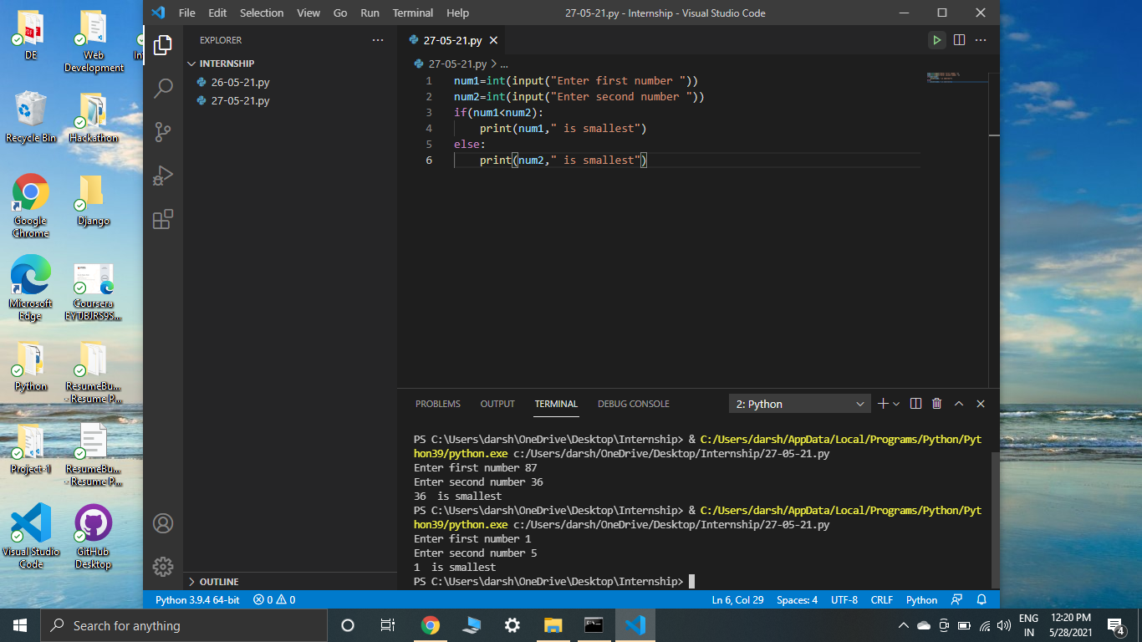

**9)**

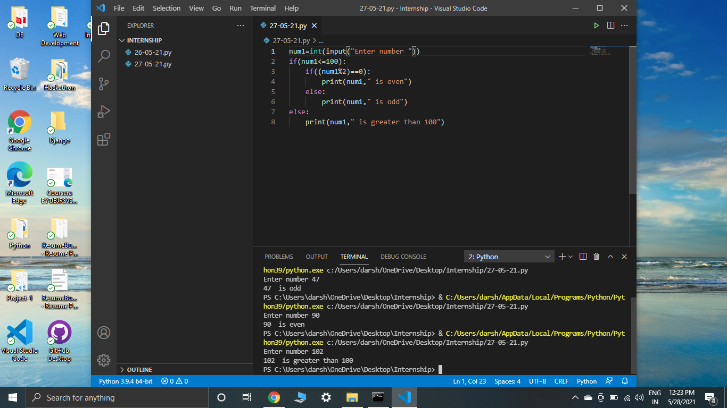

**10)**

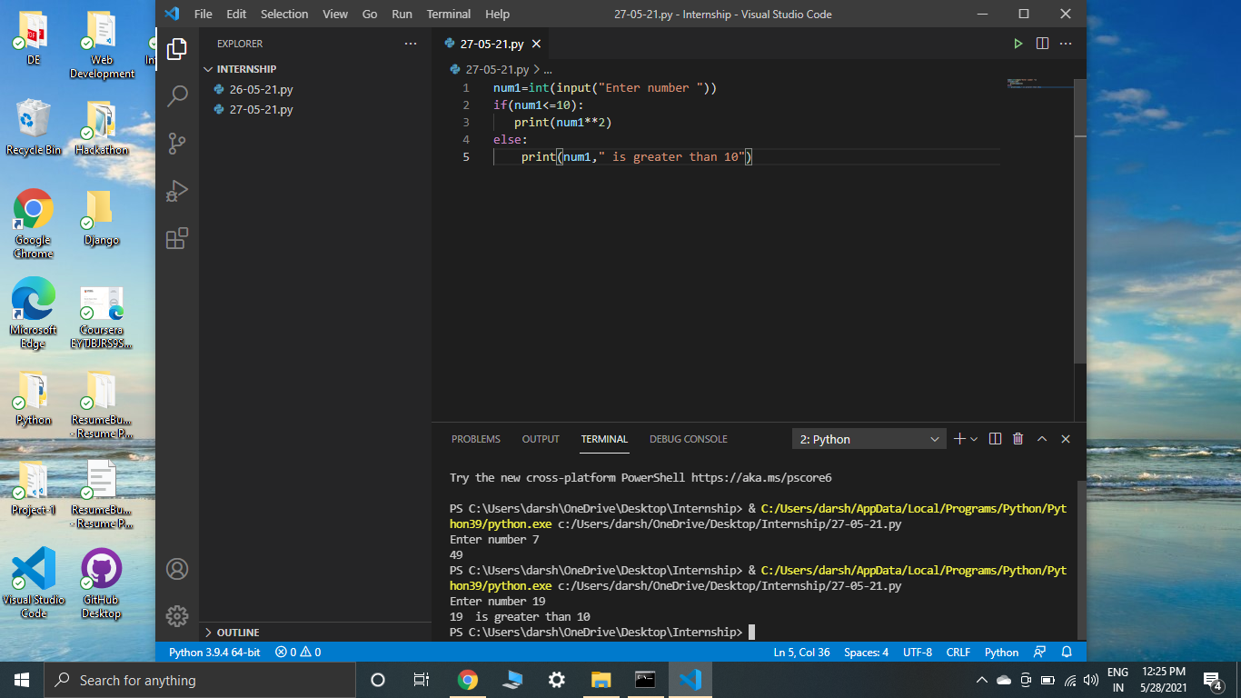

**11)**

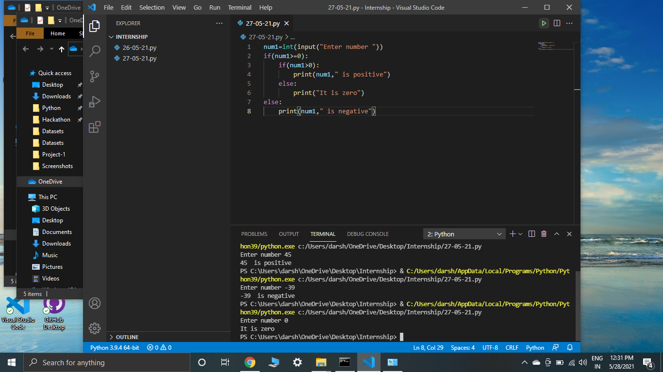

**12)**

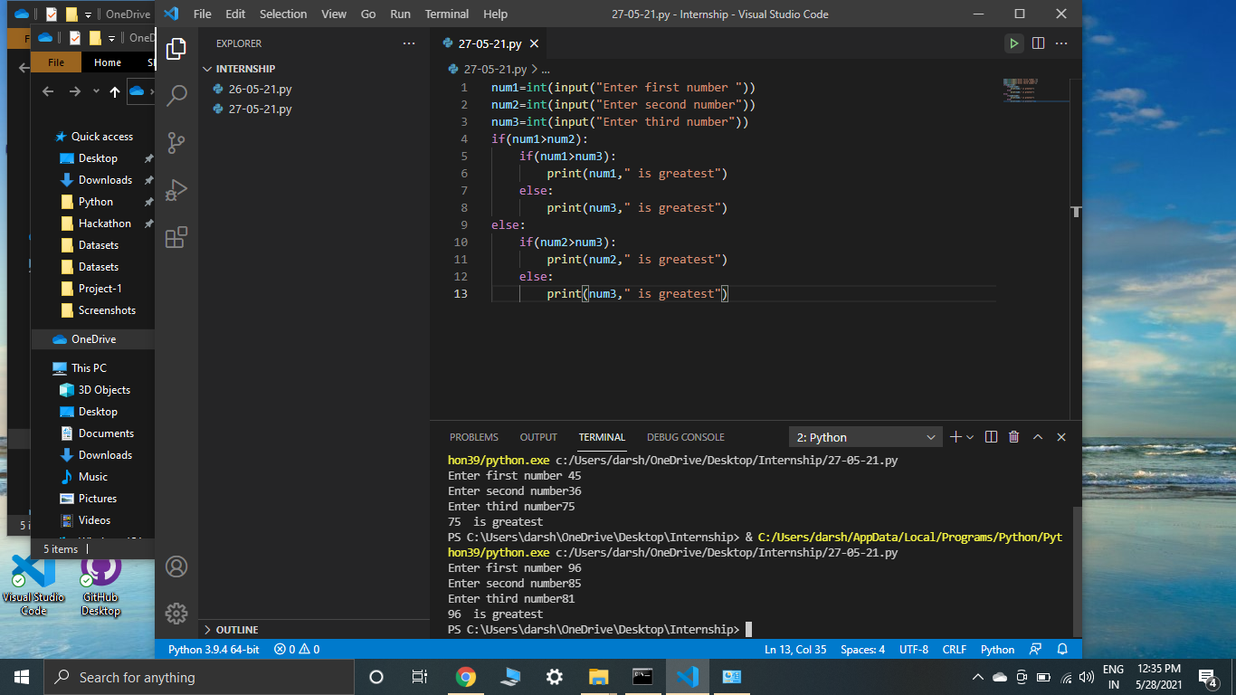

**13)**

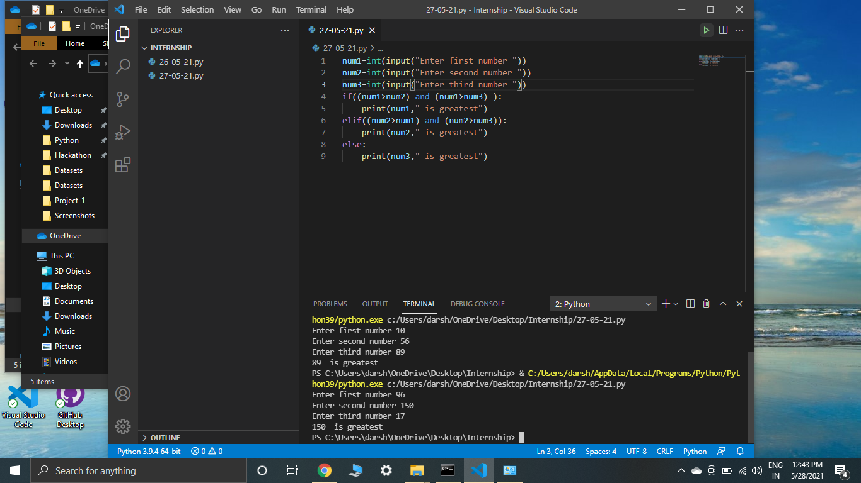

**14)**

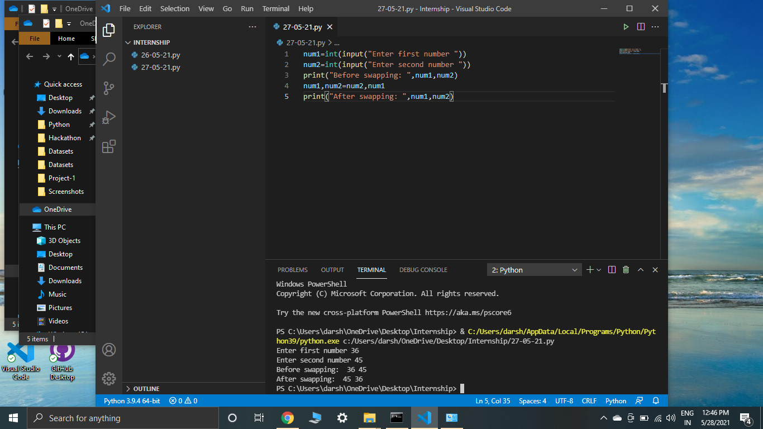

**15)**

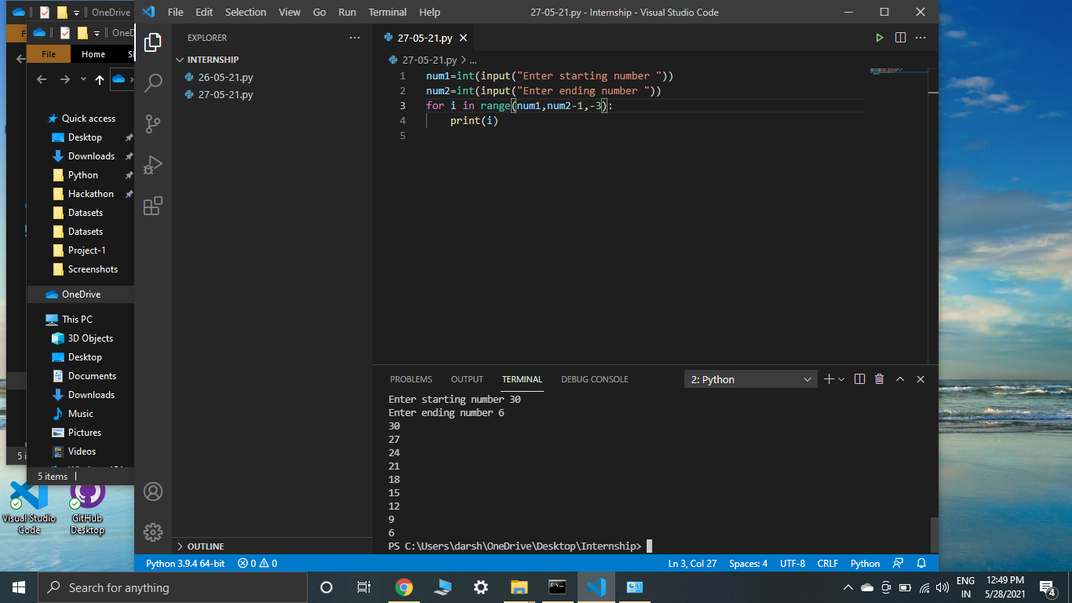

Day-4: Today’s session started with functions(methods) in Python. We were taught its syntax, how to define and call them. Then we were introduced to various types of functions such as function with no argument, function with one argument, function with return statement, function with multiple return statement, functions with default, keyword and non-keyword arguments. Then we were taught what is the use and importance of indentation in Python and modules in Python. Then we were introduced to various operators in Python.

Task: To perform what was taught in the session. Below are the screenshots.

Code:

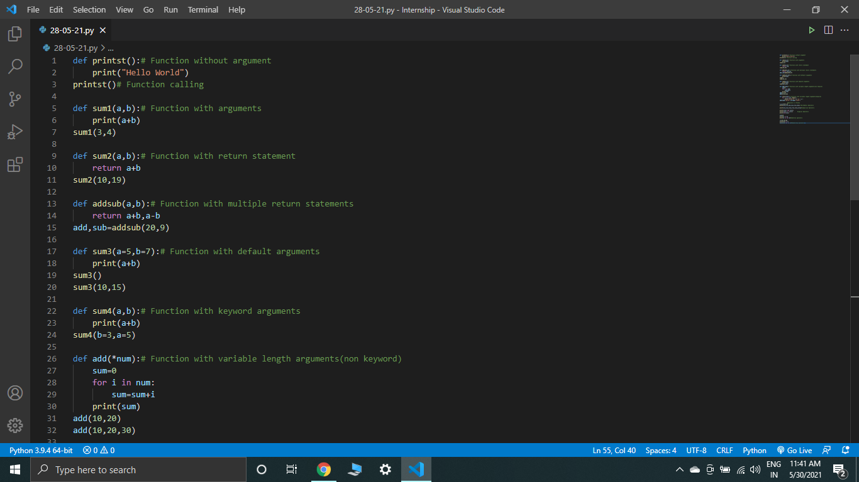

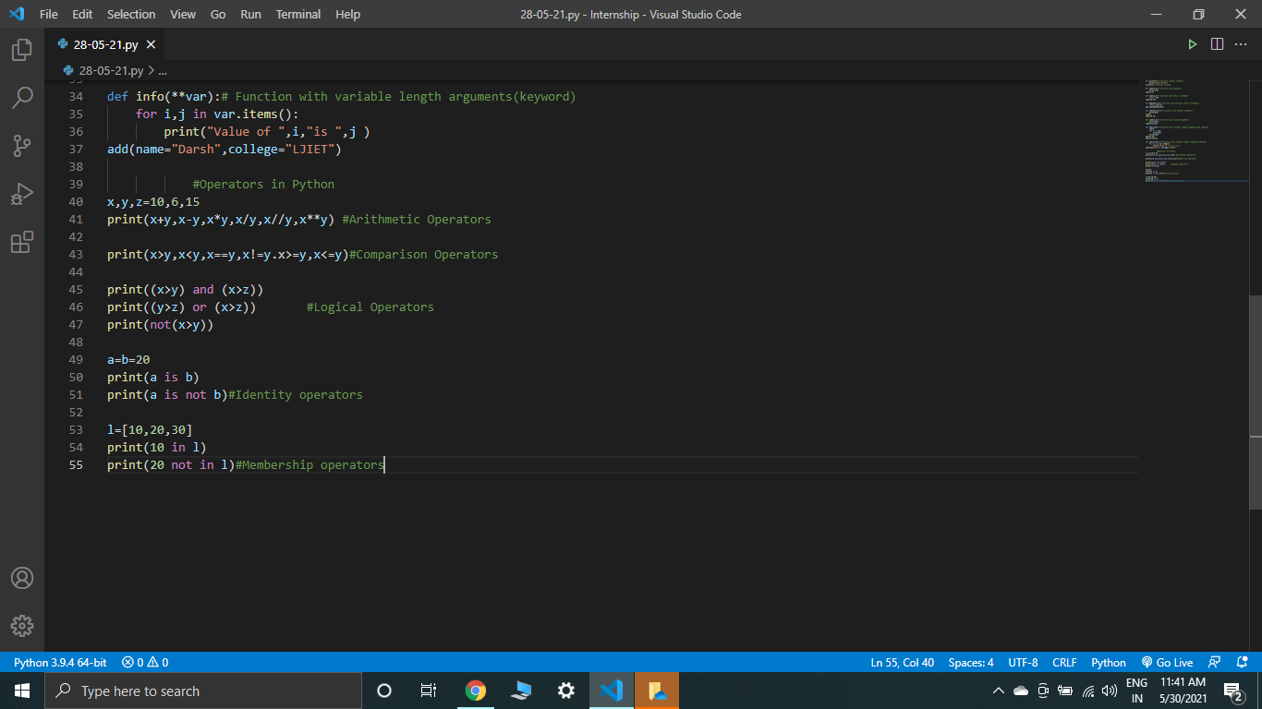

Output:

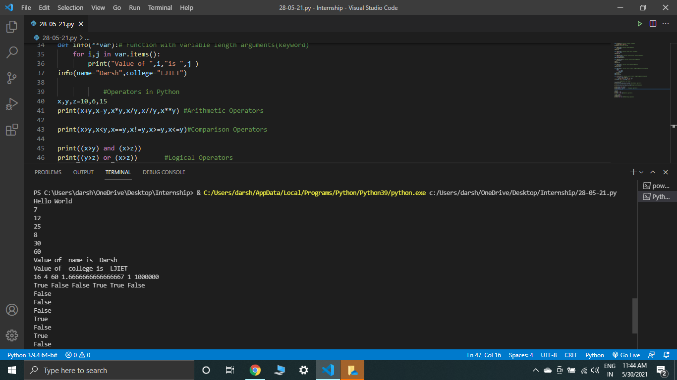

Day-7(Day-5 and Day-6 were holidays): We started our today’s session by Object Oriented Concepts of Python. We were taught what is a class, what is its importance in core Python and how we can create objects of that class. Then we were introduced to the “self” keyword. Then we performed various examples related to these. Then we were introduced to constructors, how and why they are used and how we can call them. Then we were taught various types of constructors. Then we were introduced to another Object Oriented concept known as Inheritance and various types of it. Also method overloading and method overriding was taught during this session.

Task: To perform 15 programs whose problem statements were given to us. The screenshots are given below

1)

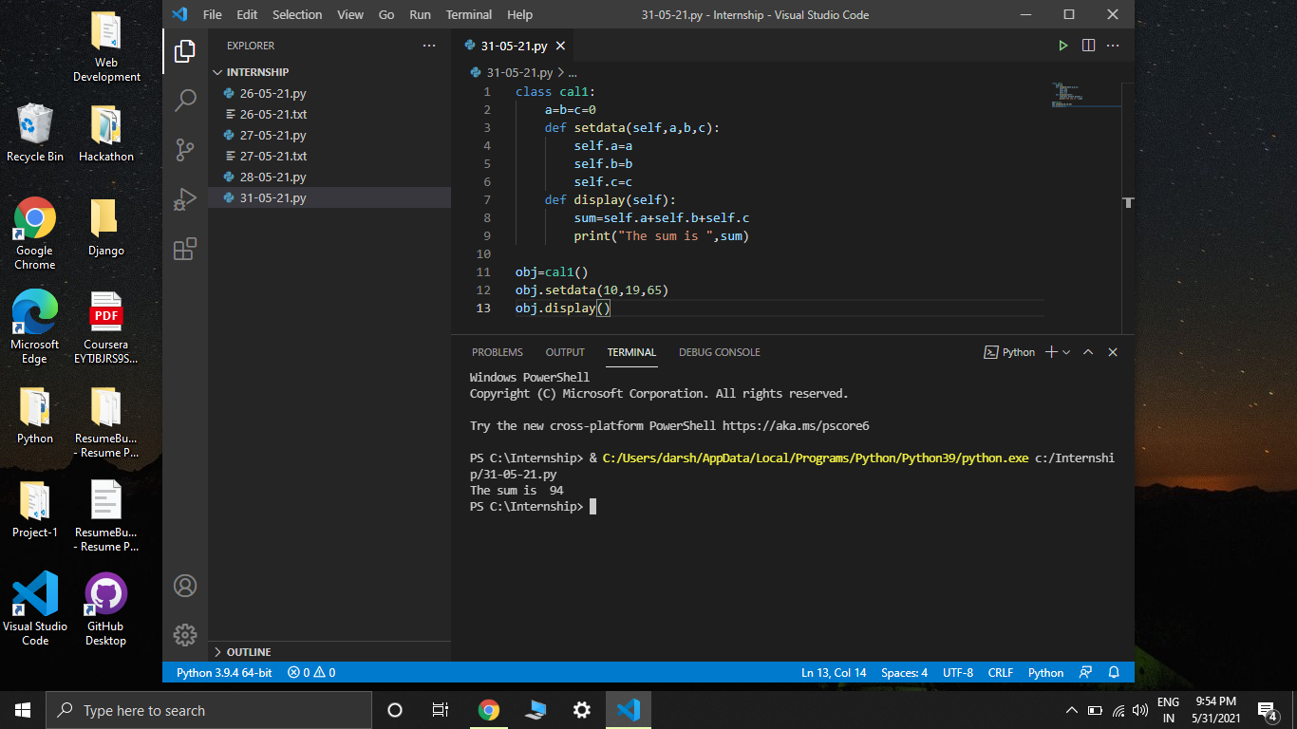

2)

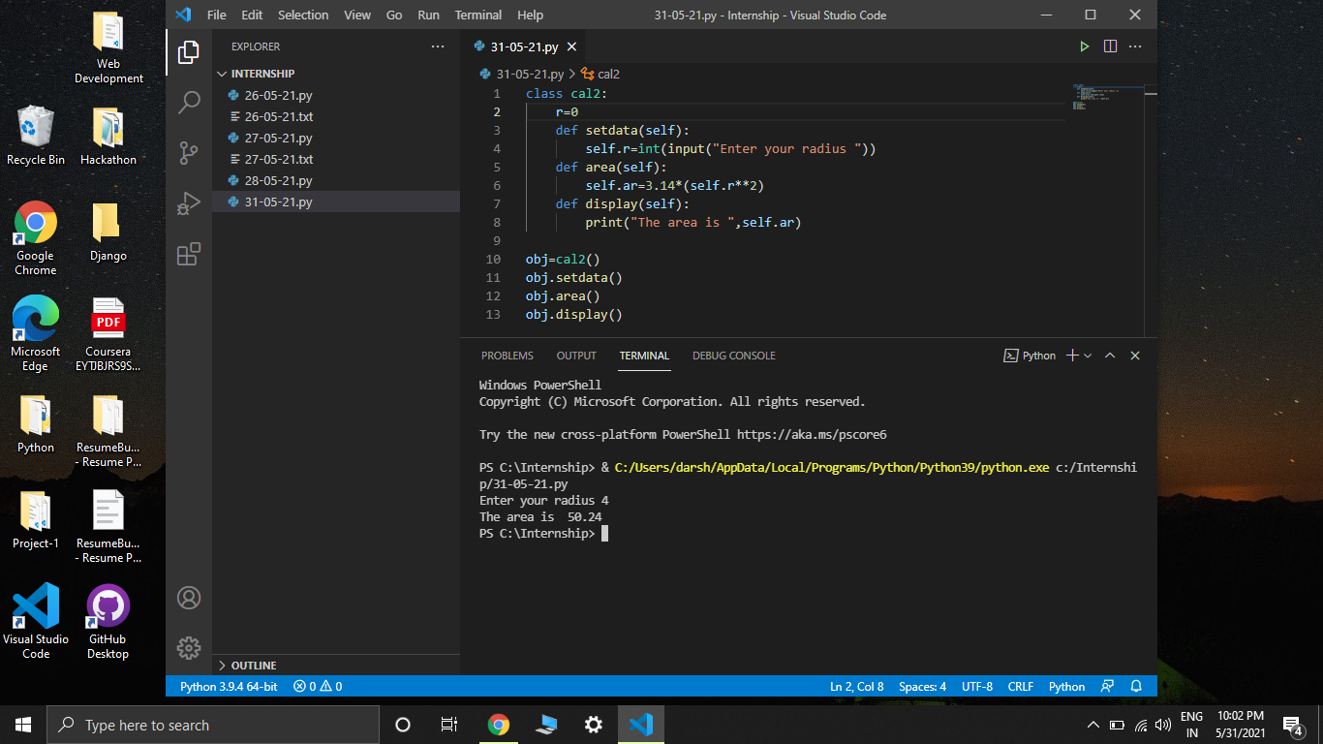

3)

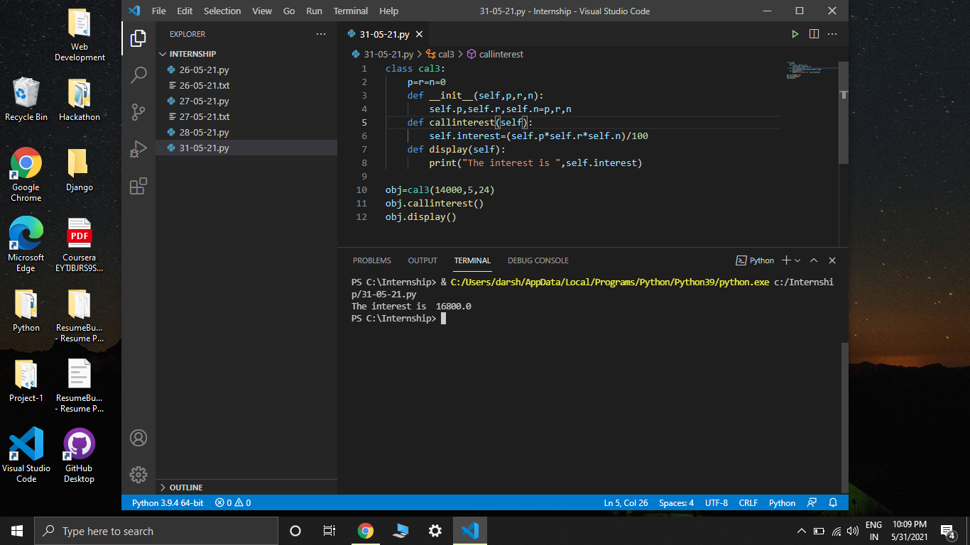

4)

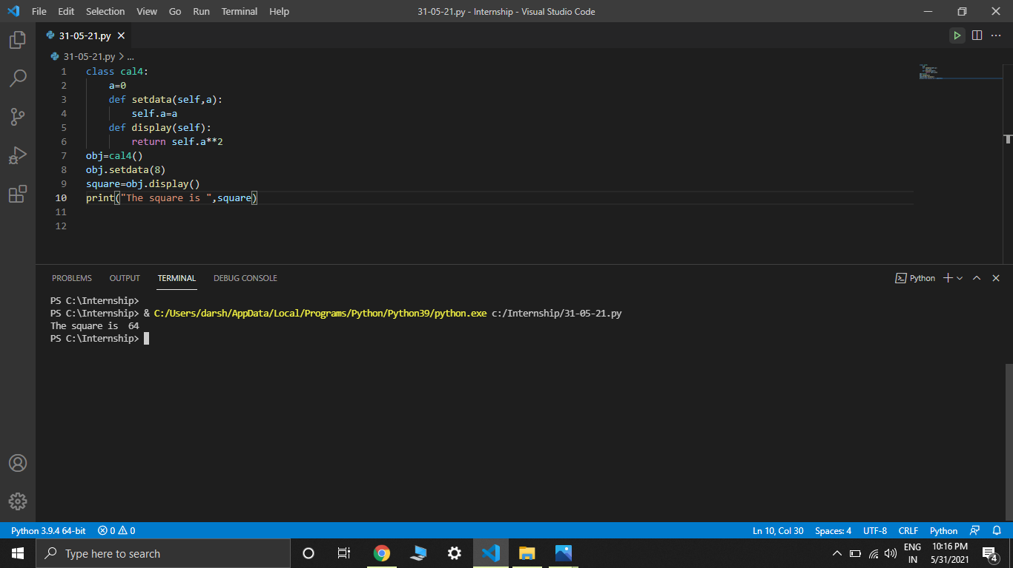

5)

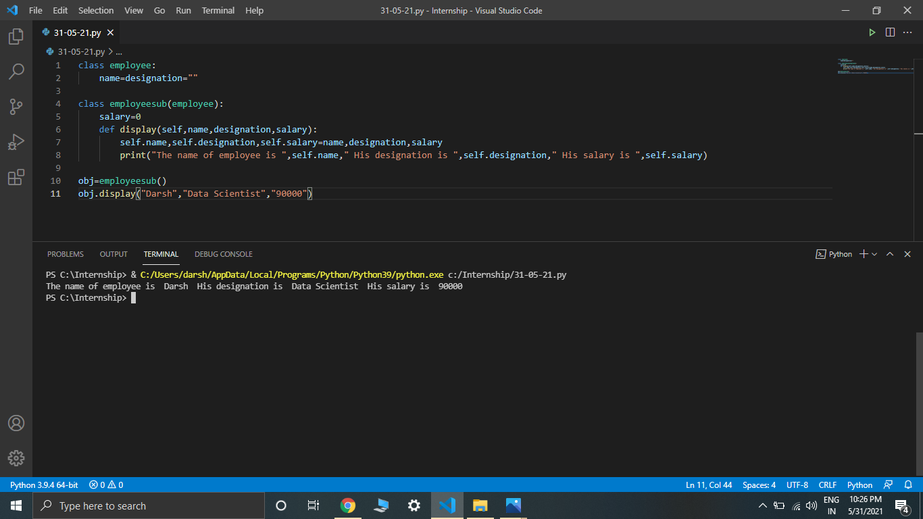

6)

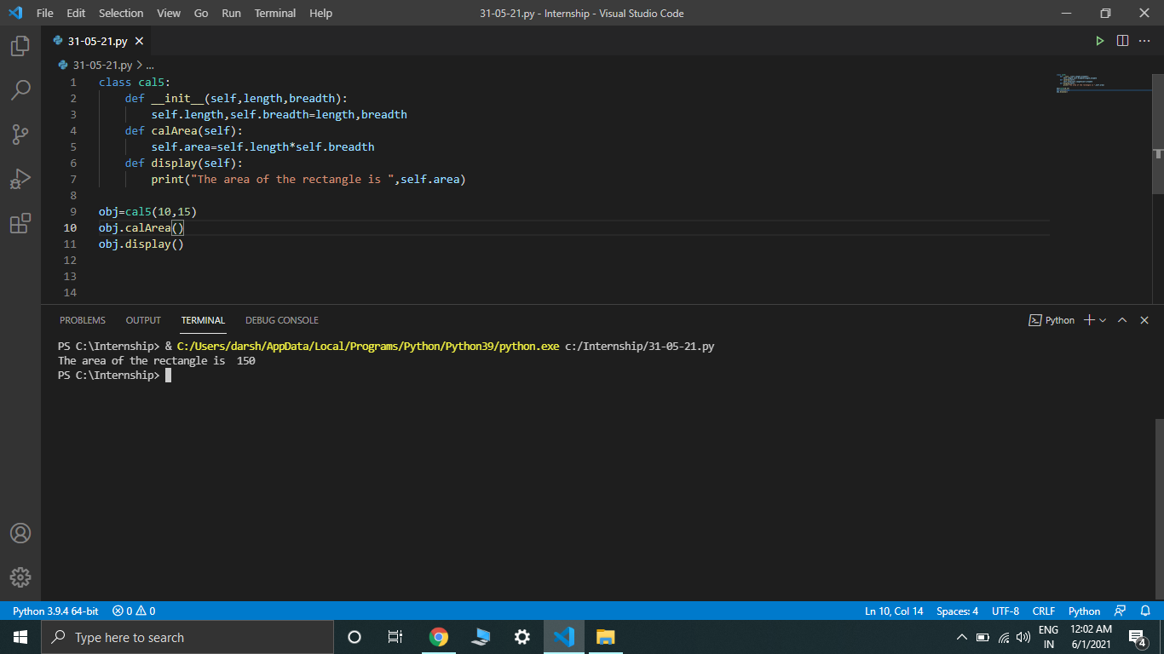

7)

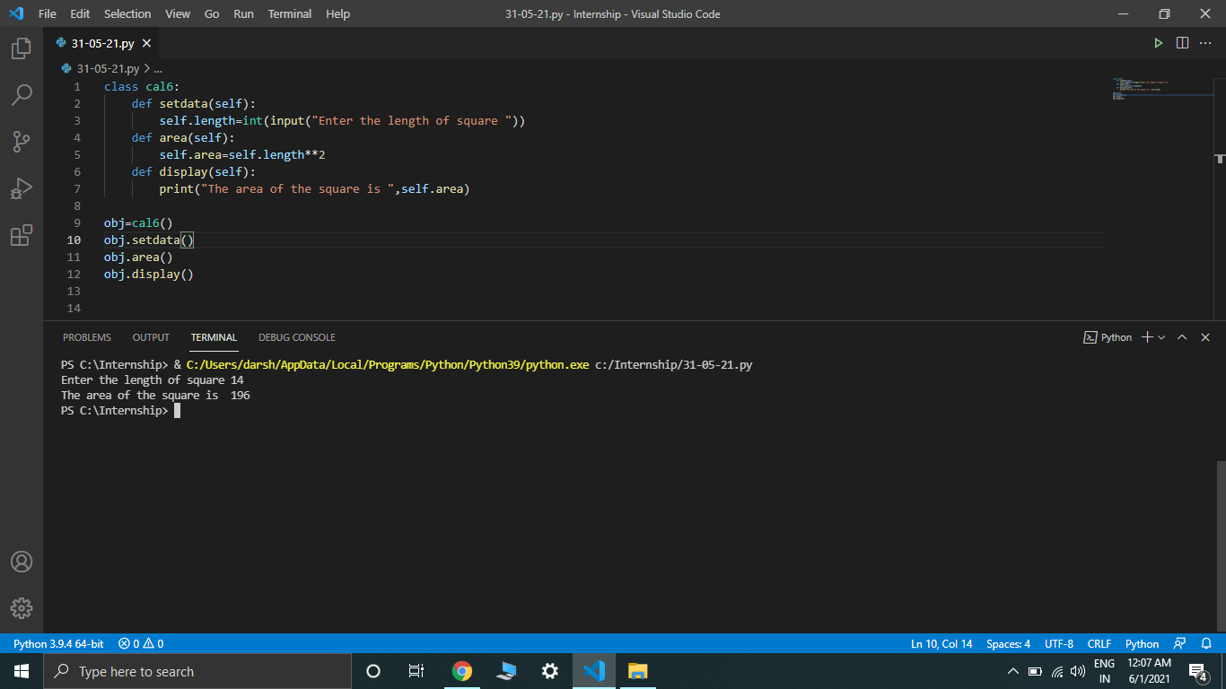

8)

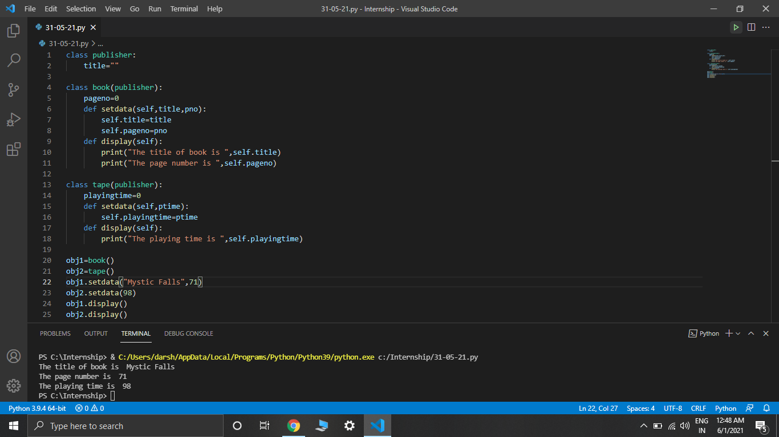

9)

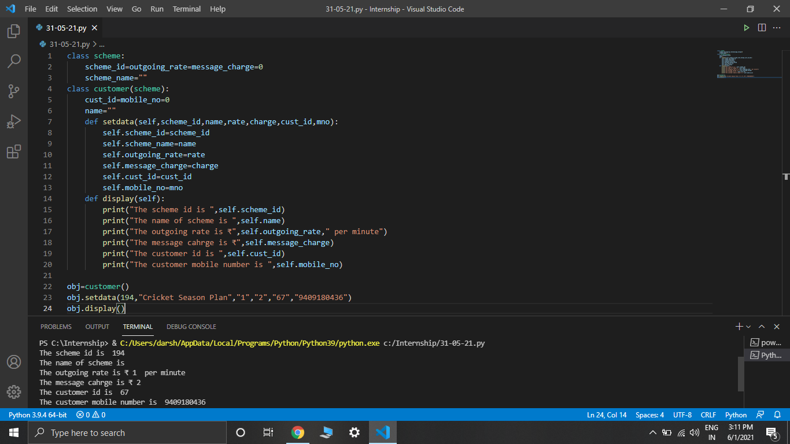

10)

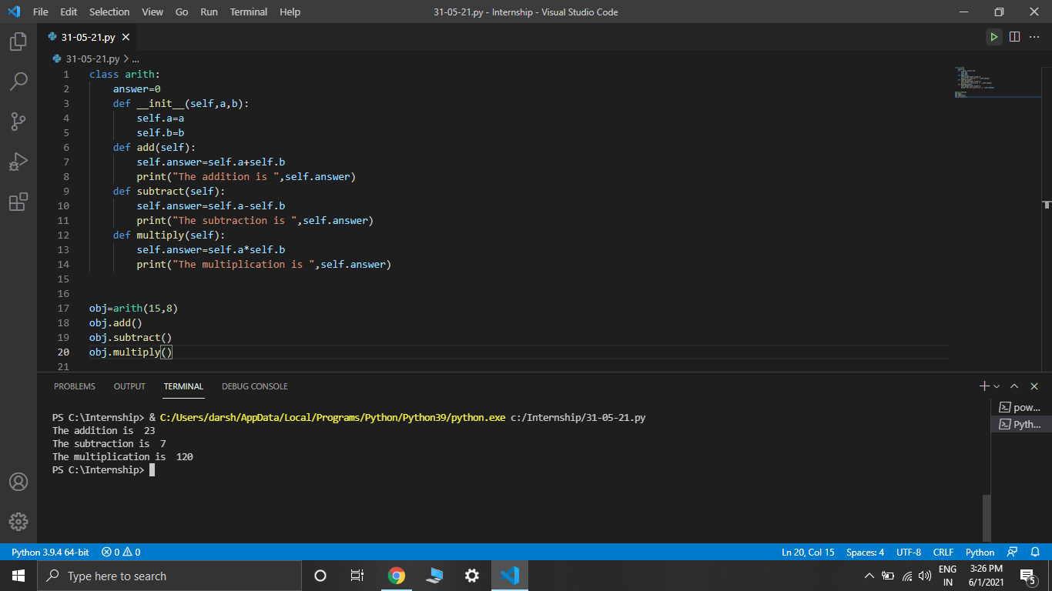

Day-8: Till now we had completed all the core Python concepts and were ready to learn Django. Django is nothing but a Python based framework used to create websites and applications. It is based on MVT(Model View Template) Architecture. It is used to provide dynamic content to websites. The session consisted of this overview of Django and how we can download it. Then we were told the uses of various files that are available in our Django project such as models, views, settings, urls etc…

Day-9: Our today’s session started with creating our first project in Django. We were taught to make a simple website which prints “Hello World”. For beginners like us, printing such a small thing was also a difficult task for us. This is because in Django different files are allocated different tasks. For example we have to use urls.py file to navigate in the website, models.py to handle databases and views.py to see what we can actually see as content in the website.

Day-10: This session started by teaching us how we can include or rather render html files in our website. We were now slowly moving ahead in creating an actual website. We created html files for each menu on our website. Then we were introduced to the concept of layout in websites and how we can implement it. Next we were taught how to create forms on websites. We all know that most websites contain a signup or a registration form on them. Then we were also taught how we can include HTML and CSS templates in our website and what is the use of static.

Task: I have performed a single project that contains all the things taught on Day-8, Day-9 and Day-10. The screenshots of codes are given below.

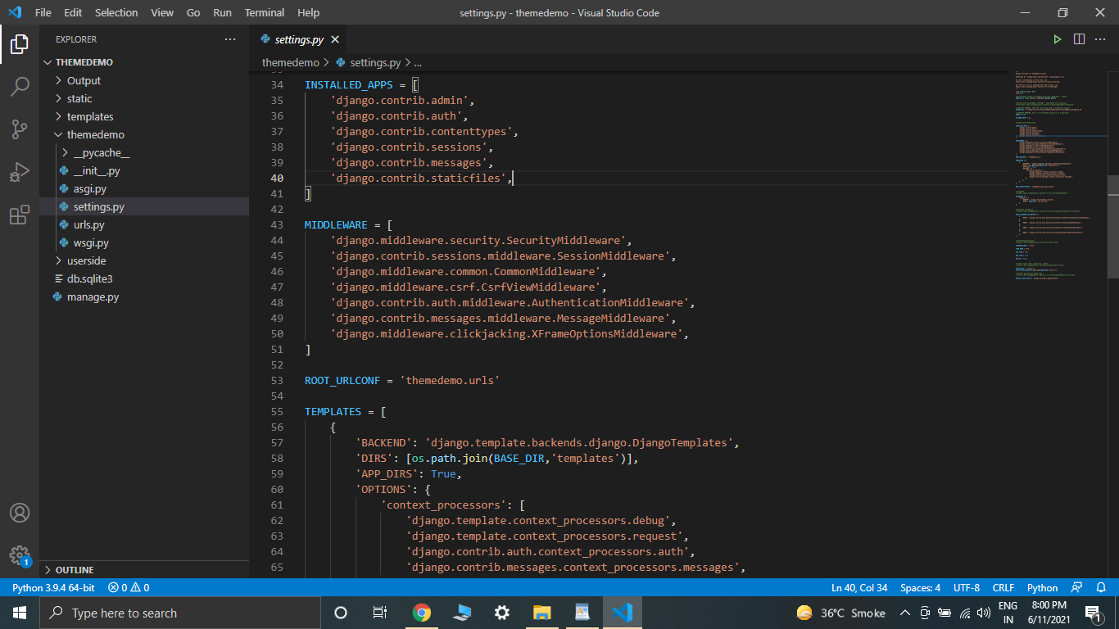

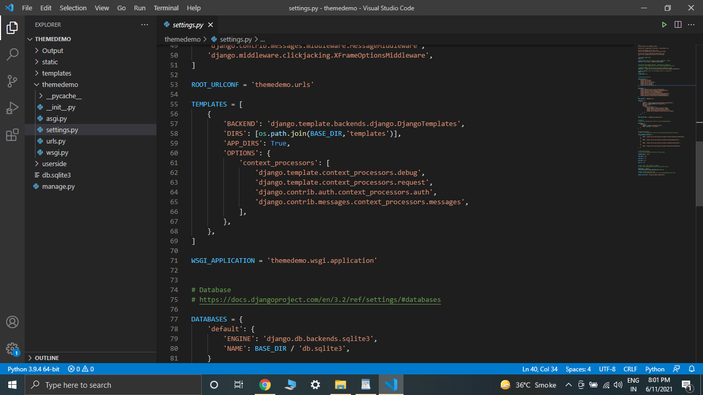

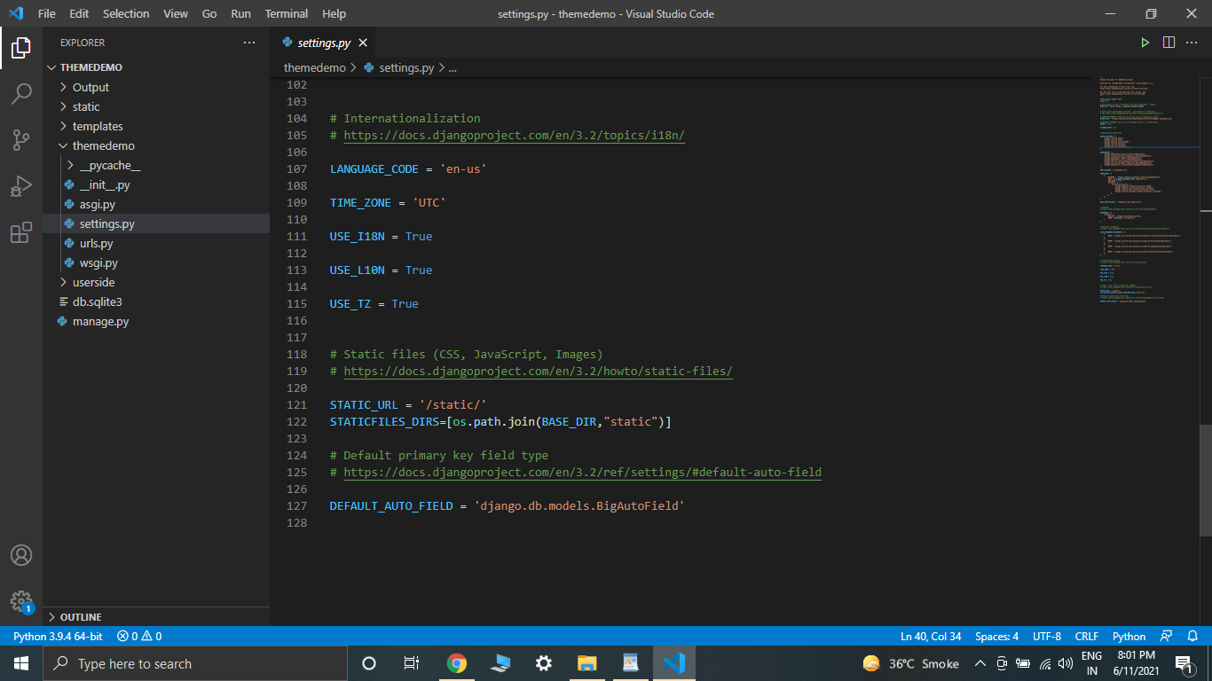

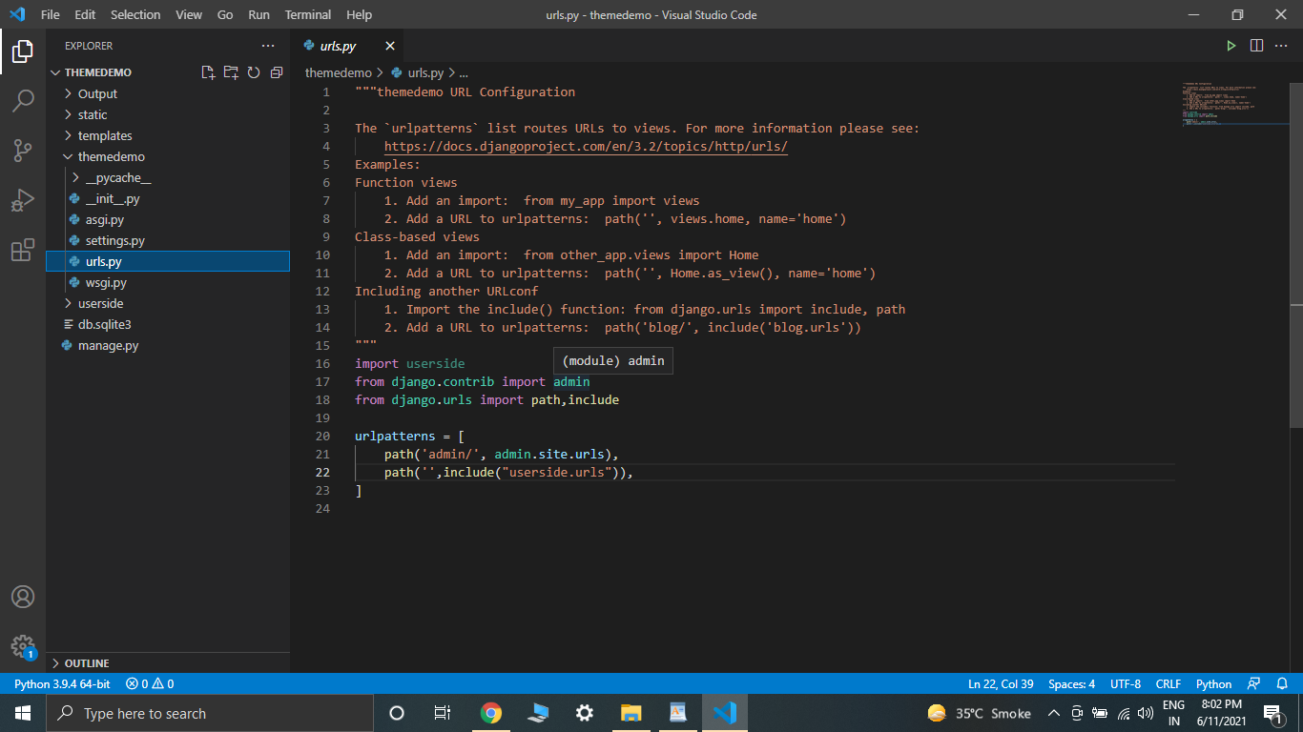

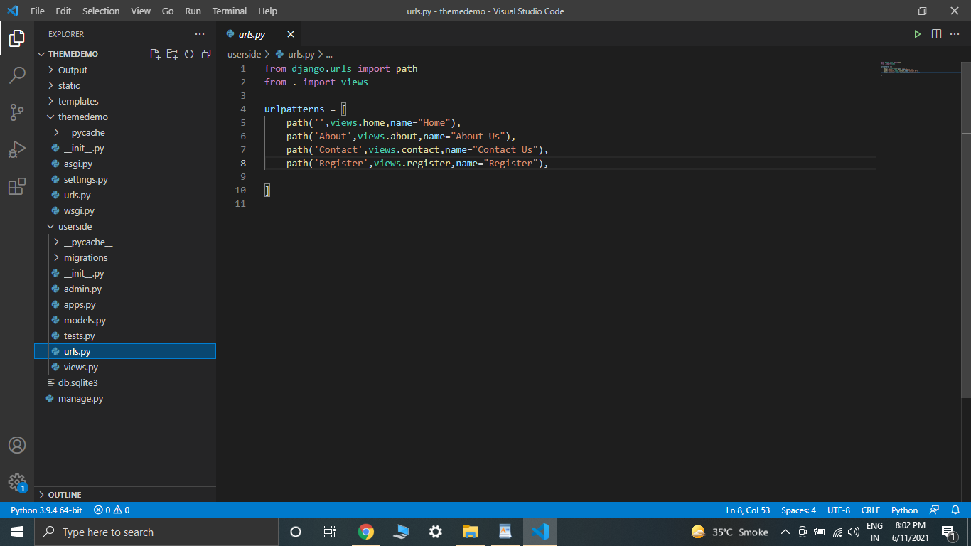

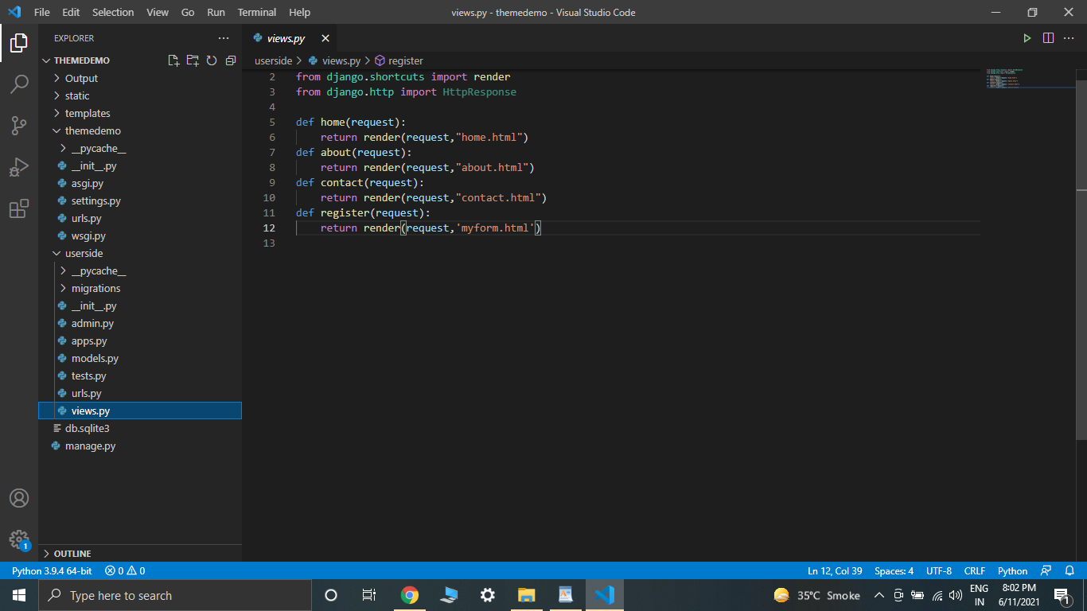

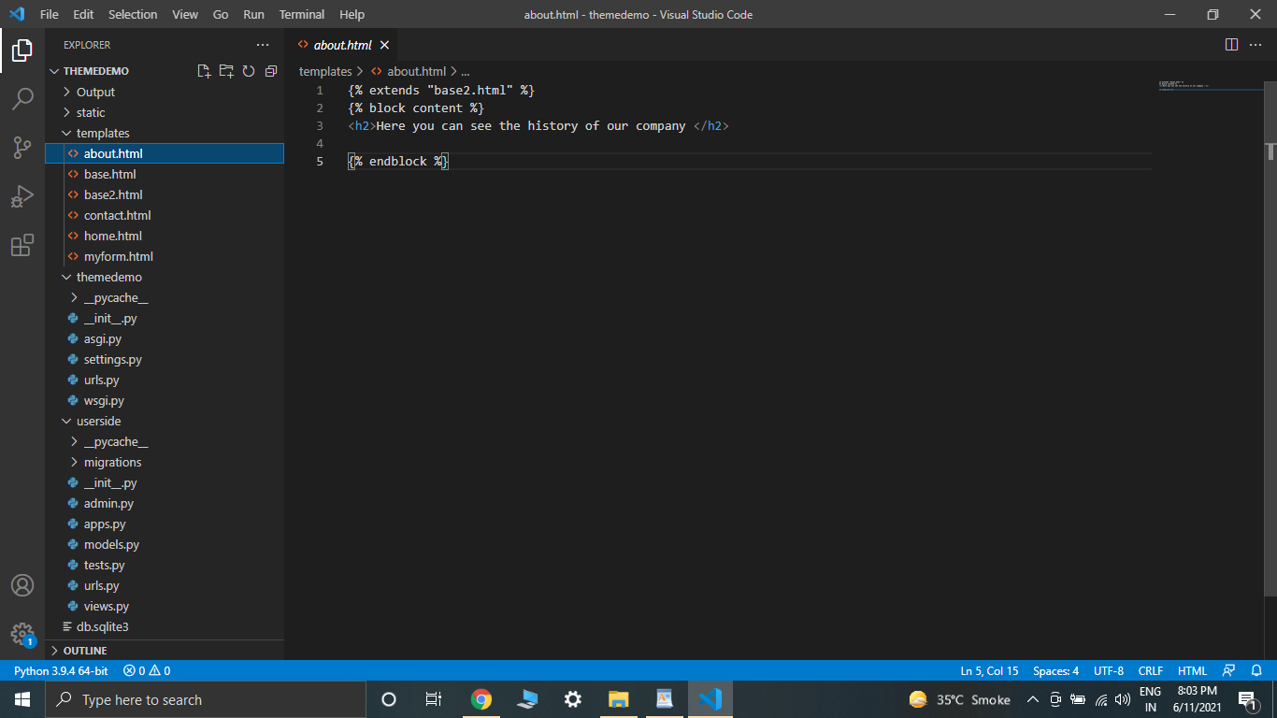

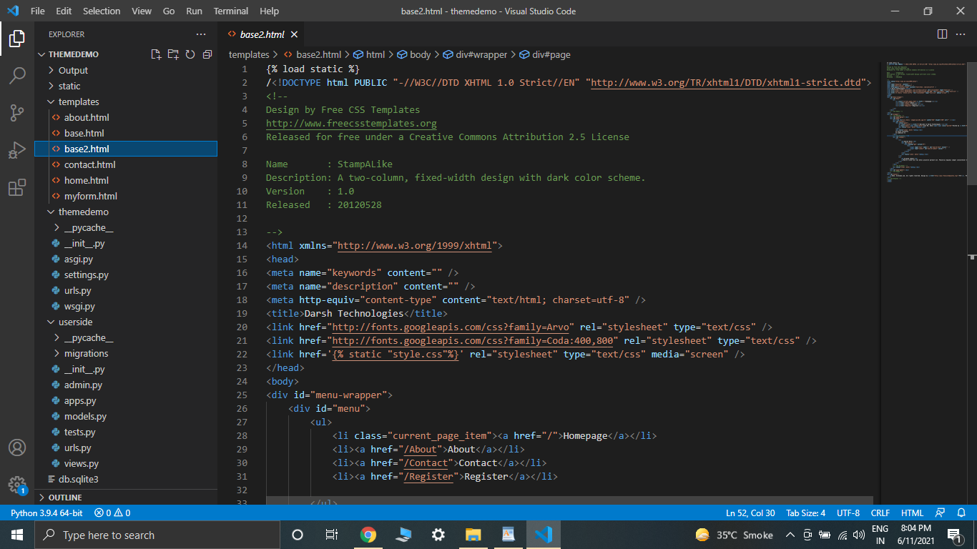

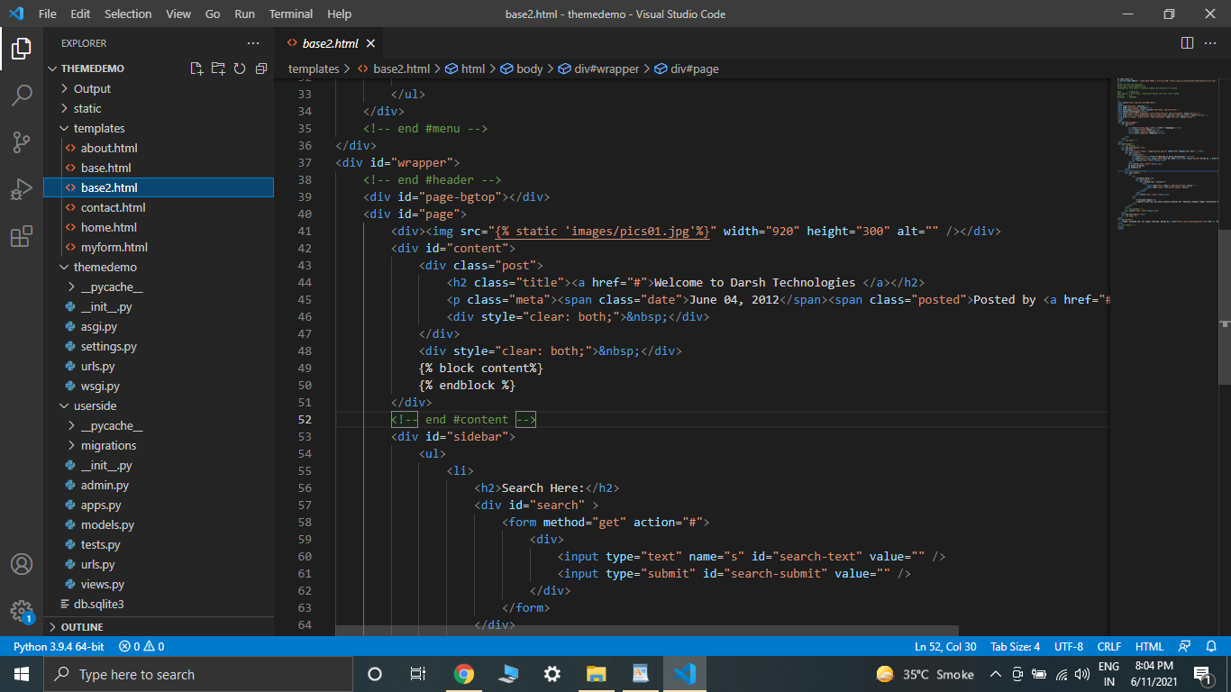

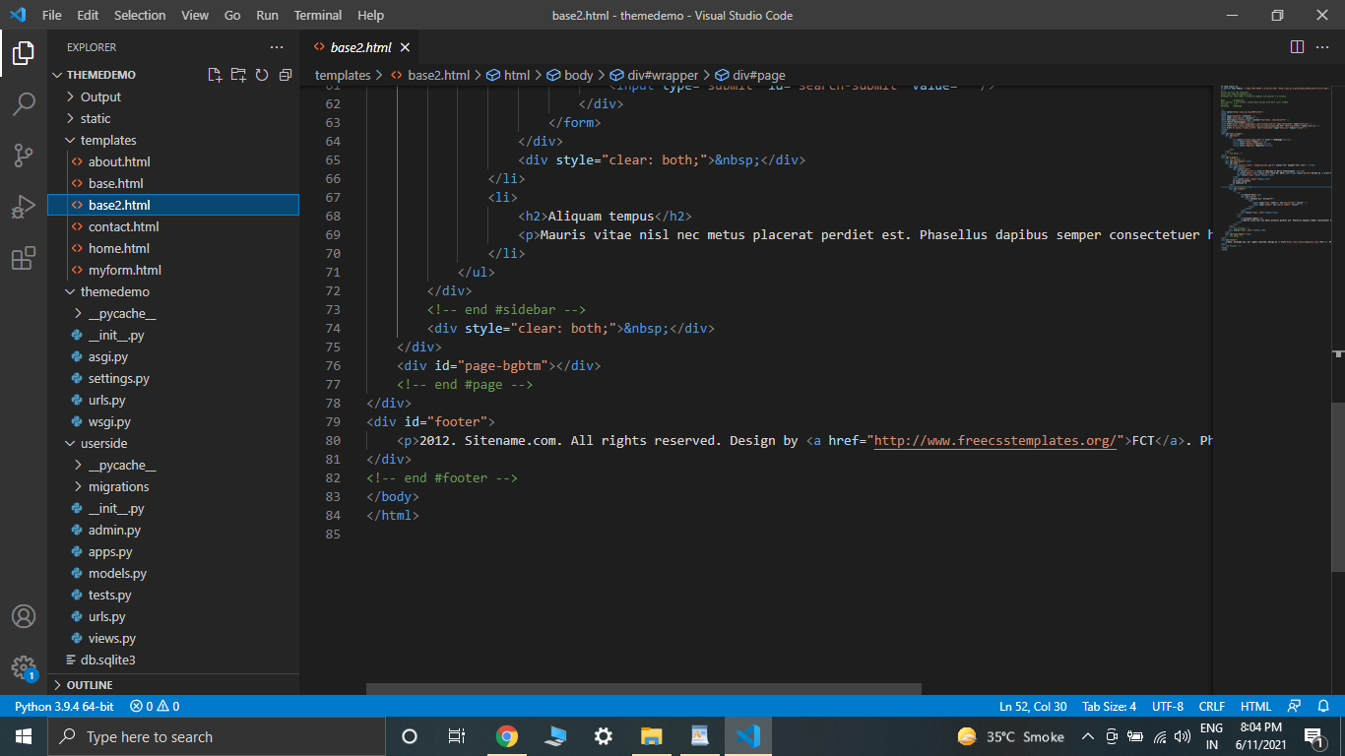

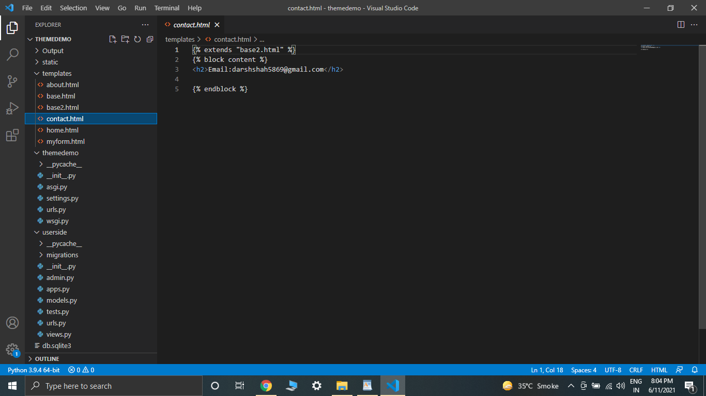

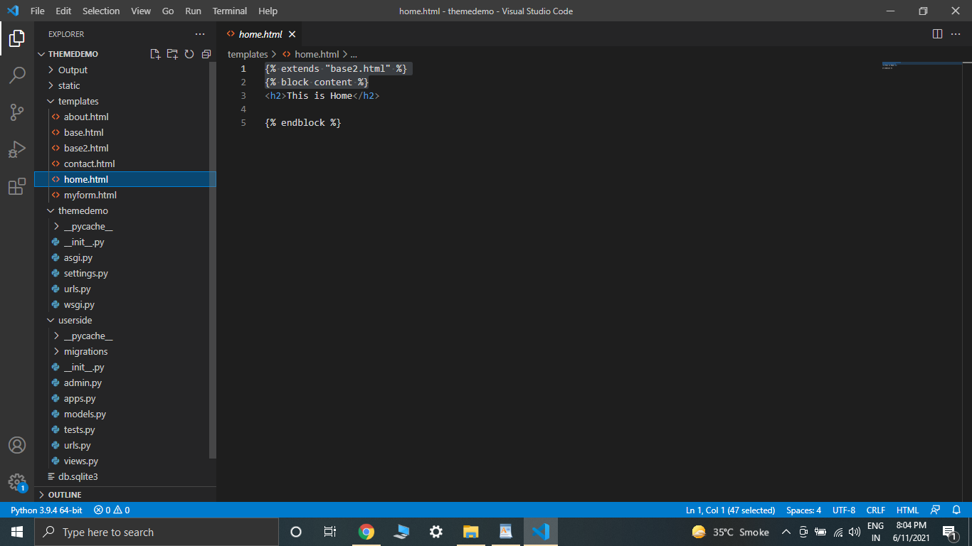

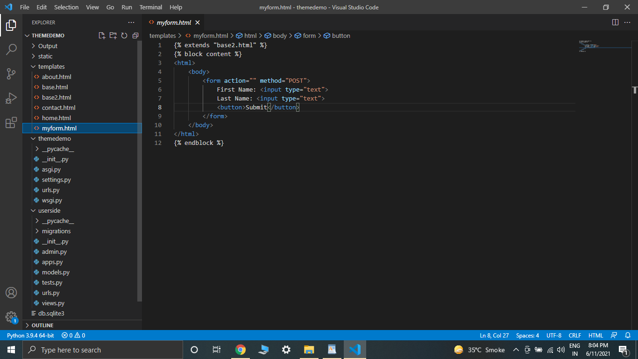

Output:

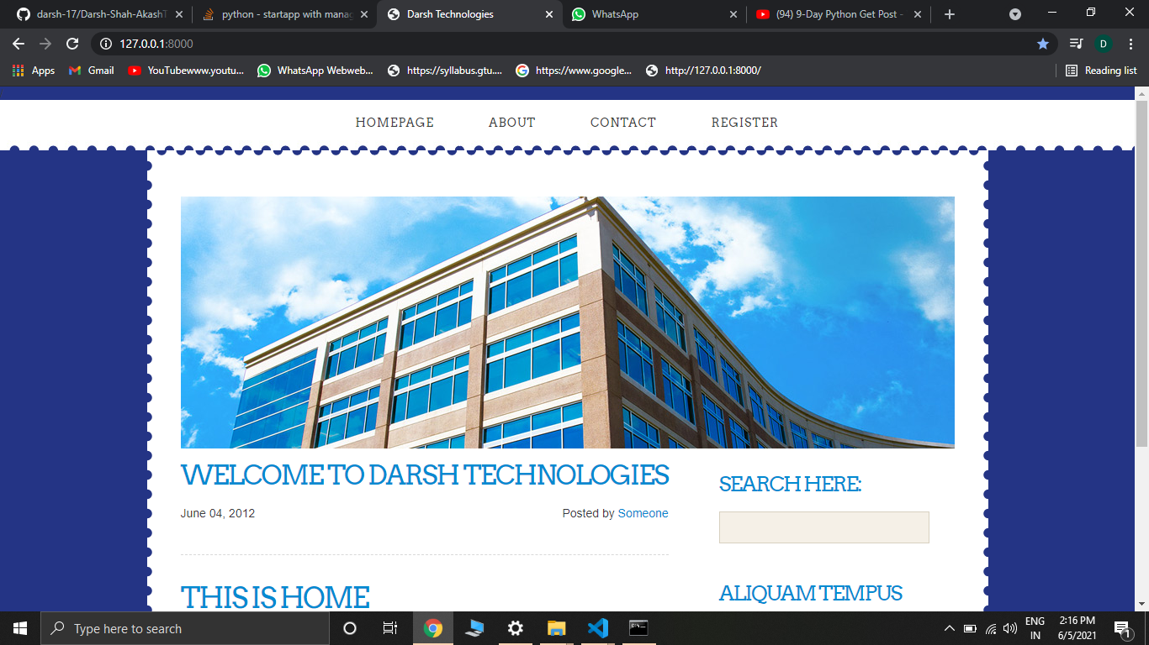

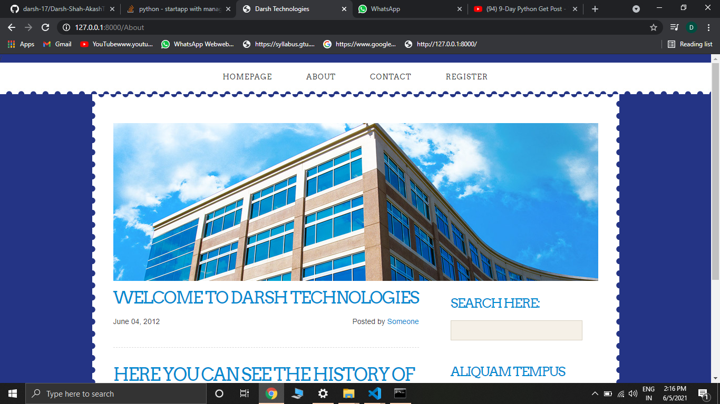

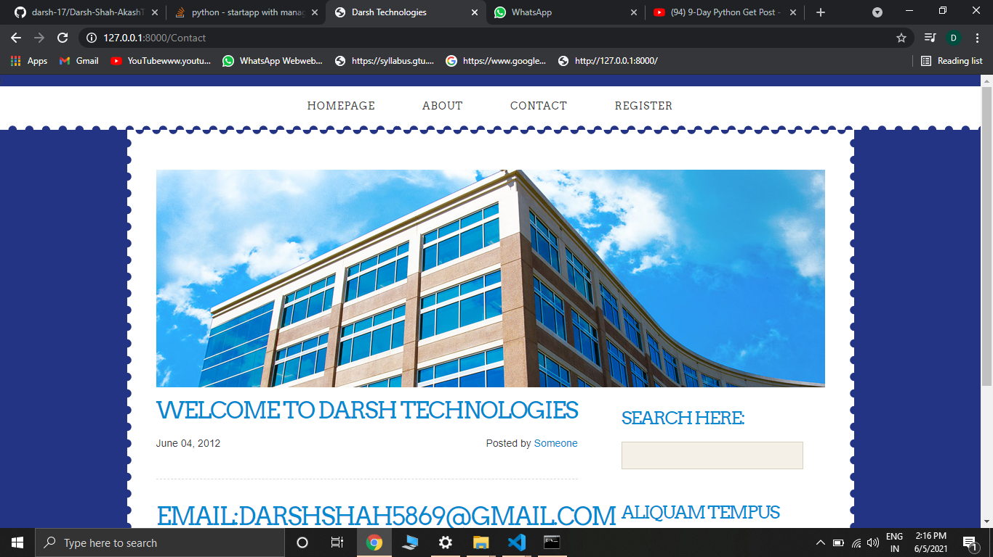



Day-11: This session started by introducing us to GET and POST HTTP methods. We were taught how and where both these methods are used almost on all websites and how they differ from each other. Then we were taught how we can show dynamic data on our website using jinja. We also performed an example where we created a simple calculator website which prints the sum of two numbers.

Task: To create a simple registration form in a website and to display the data entered.

Code:

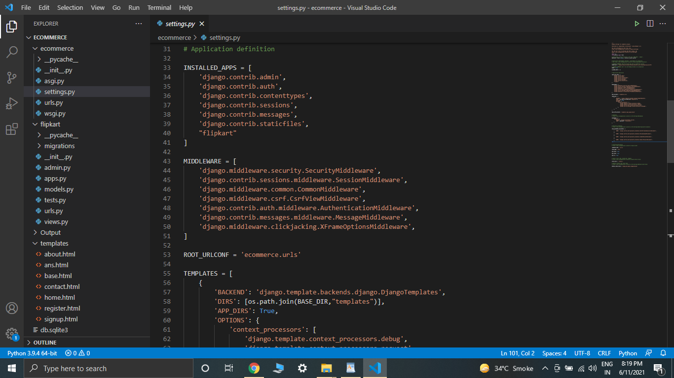

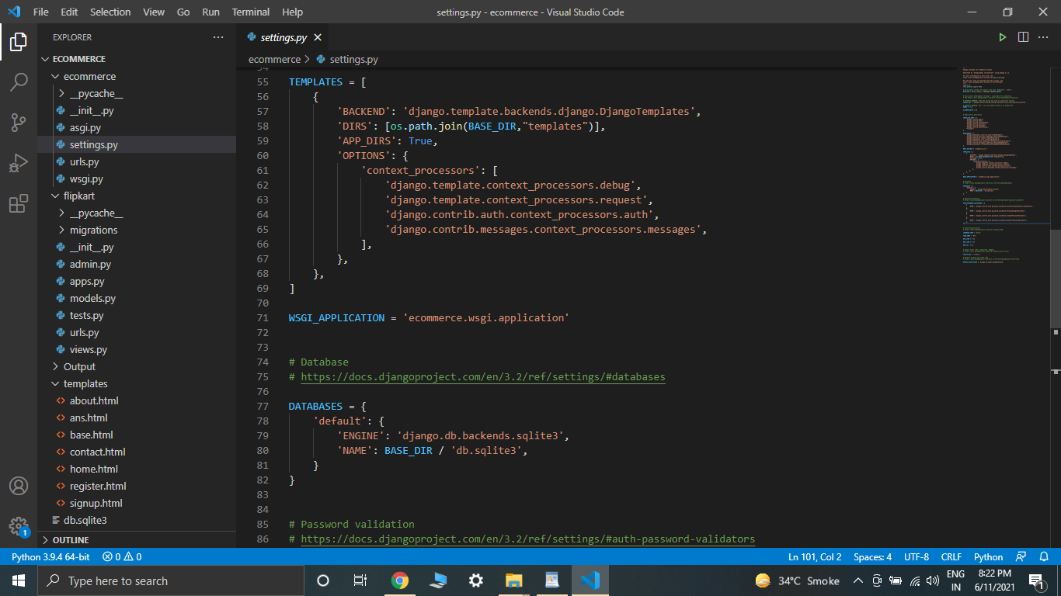

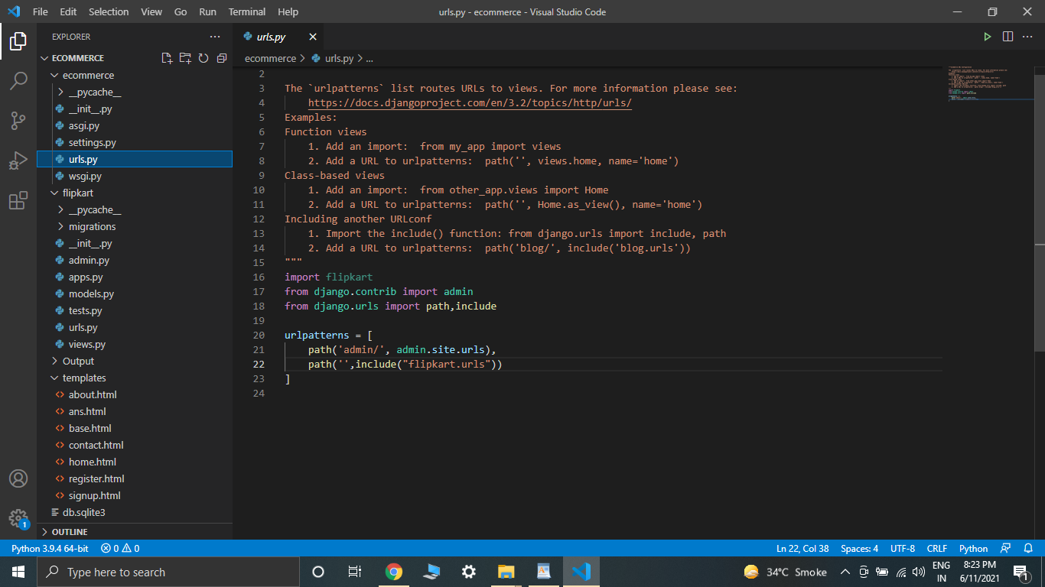

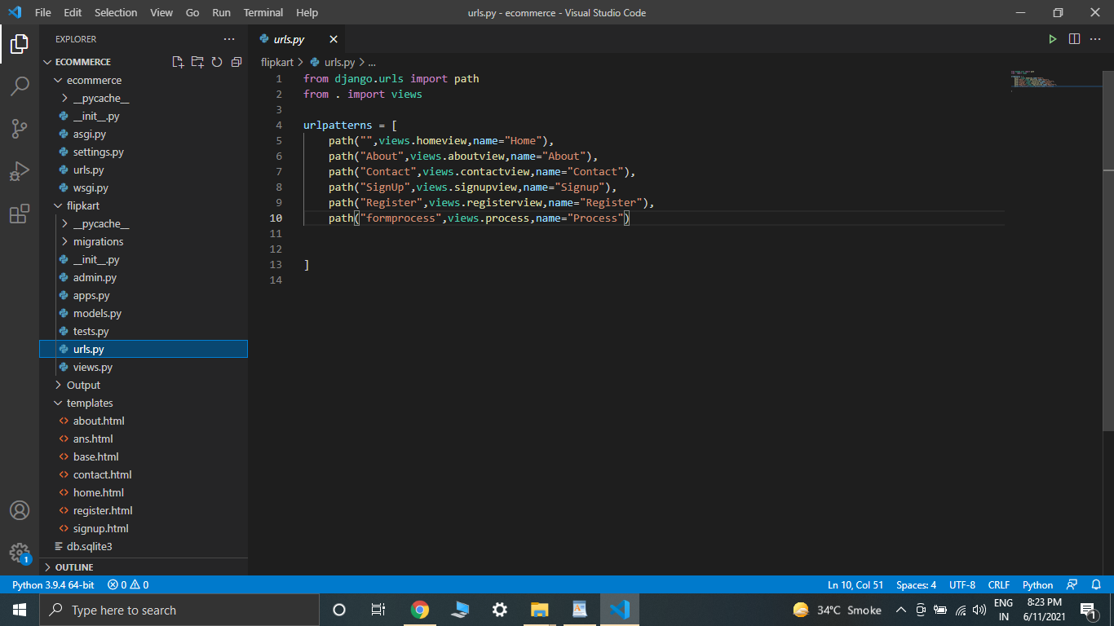

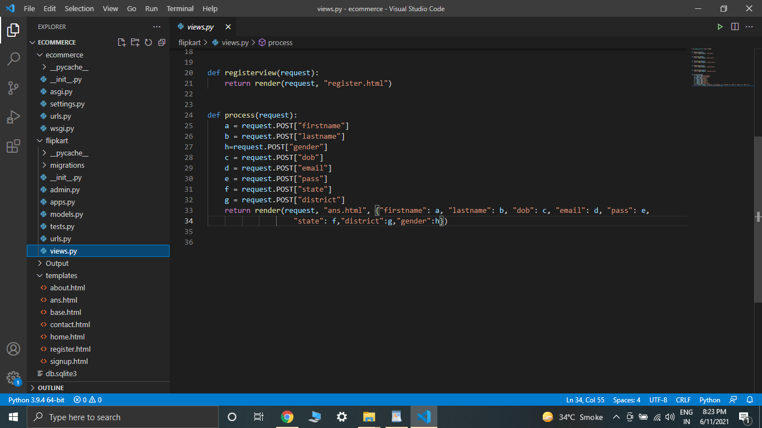

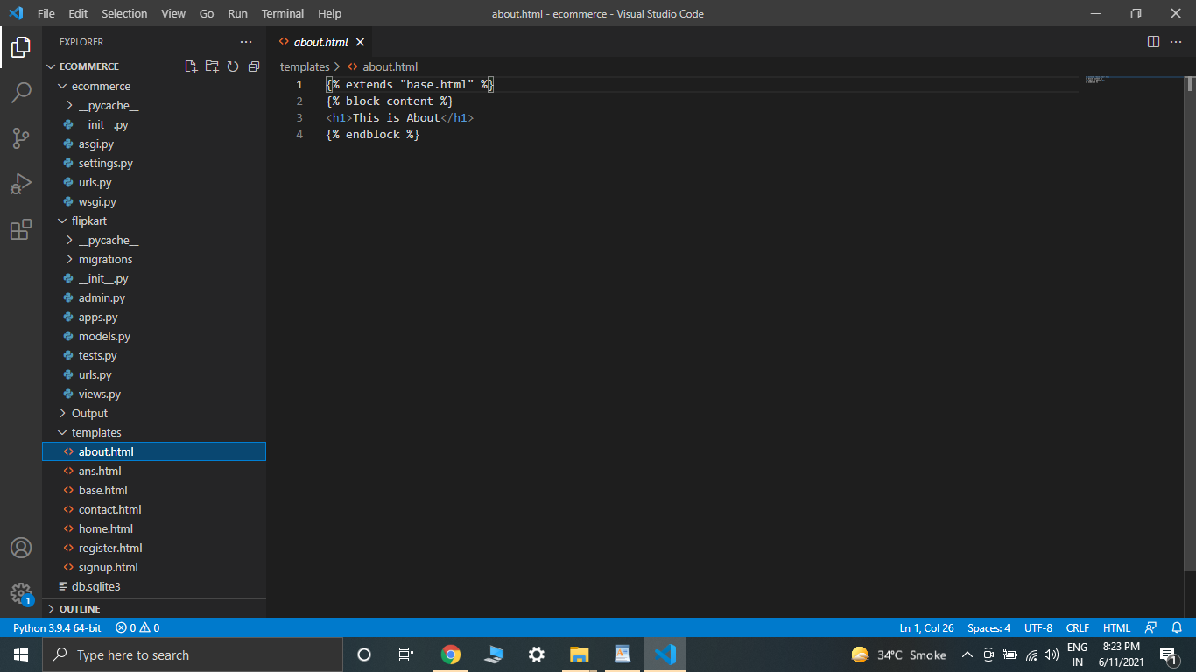

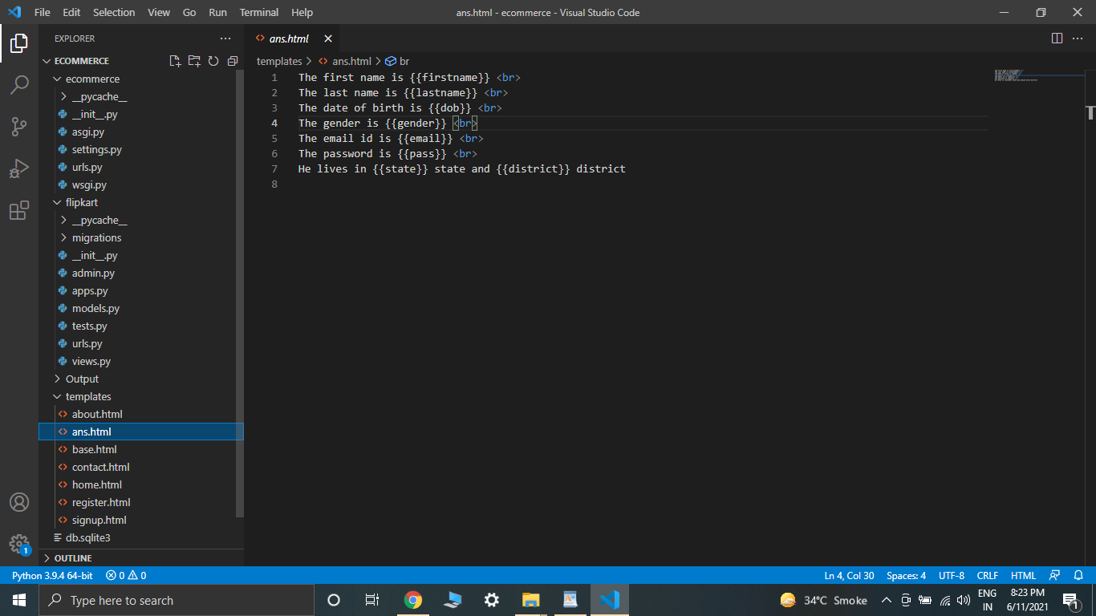

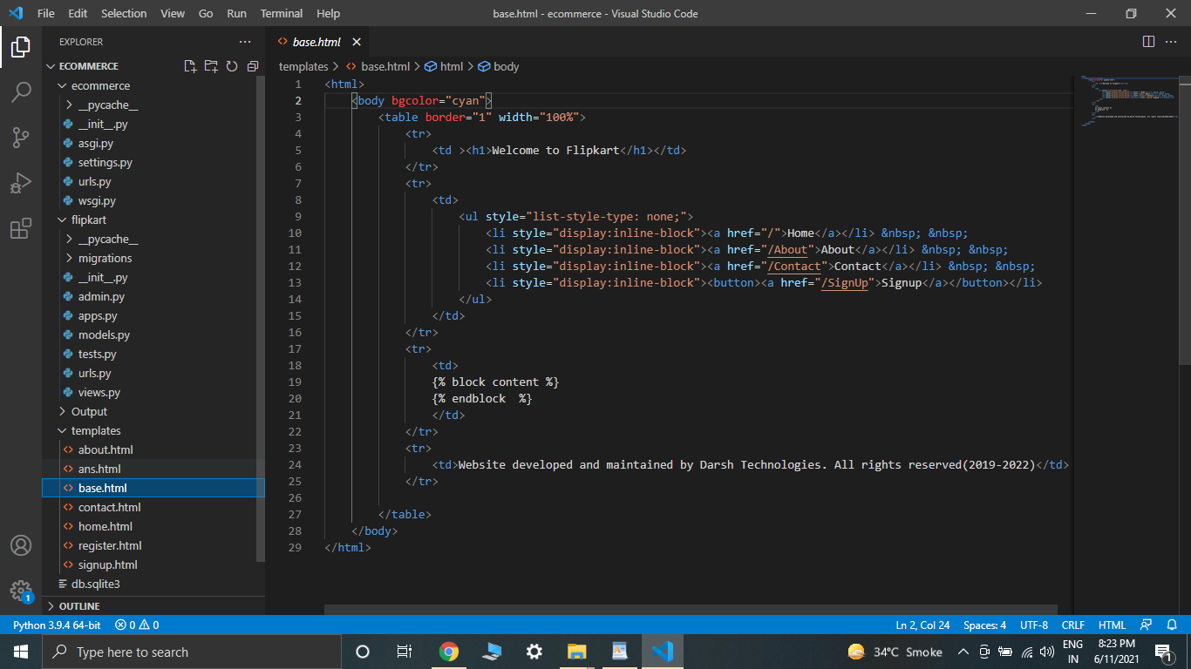

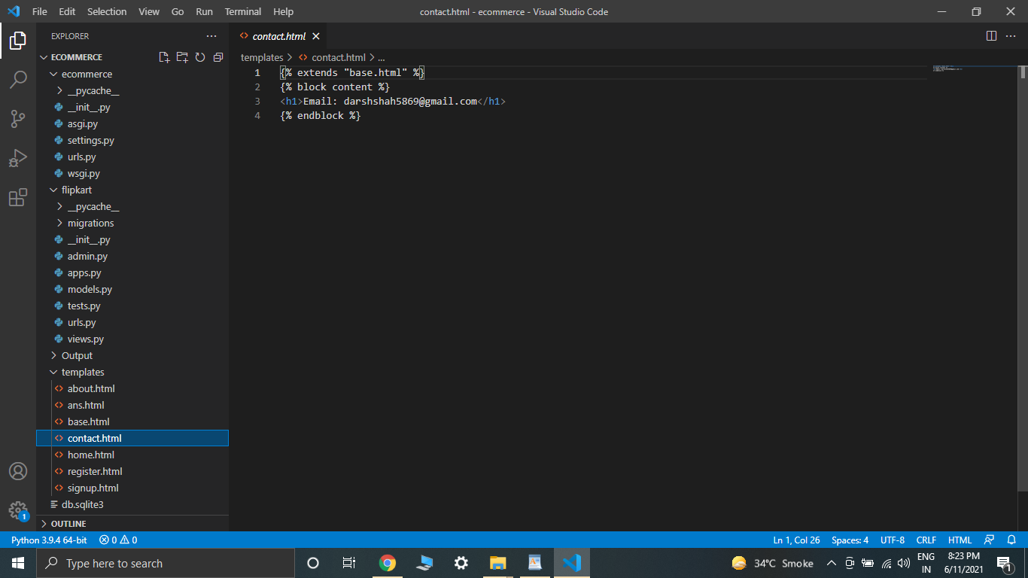

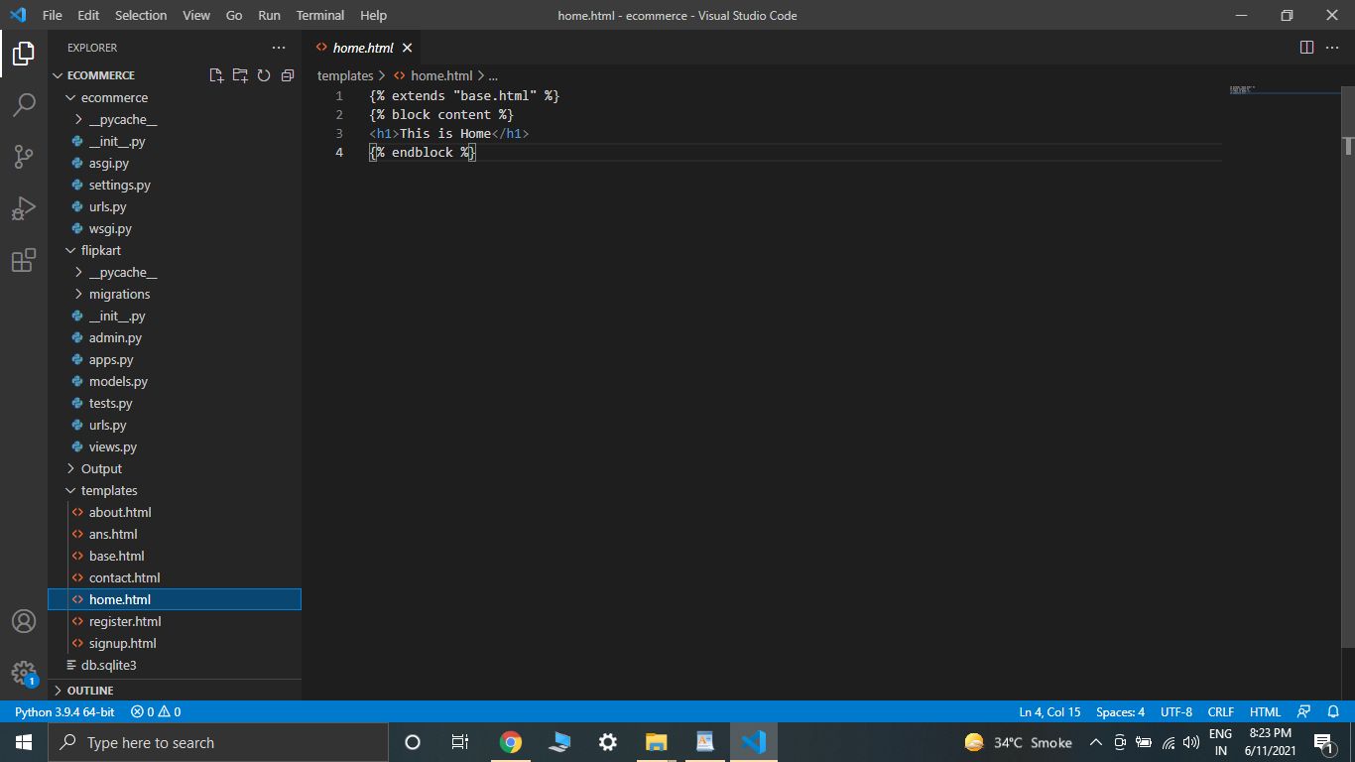

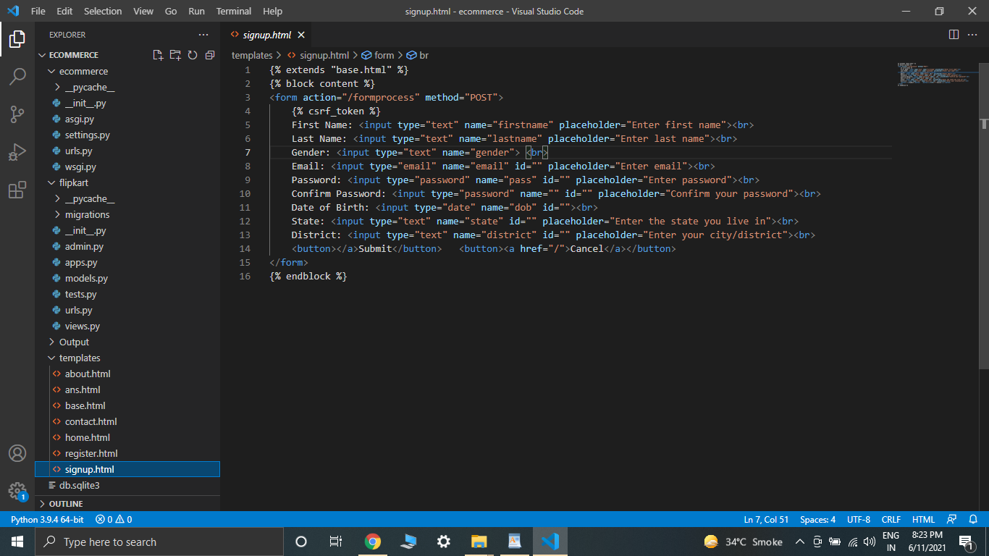

Output:

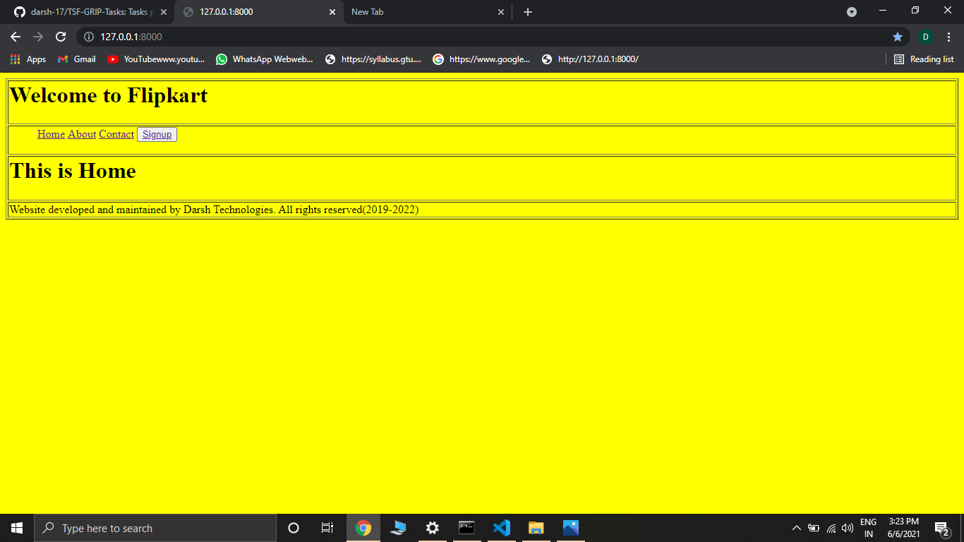

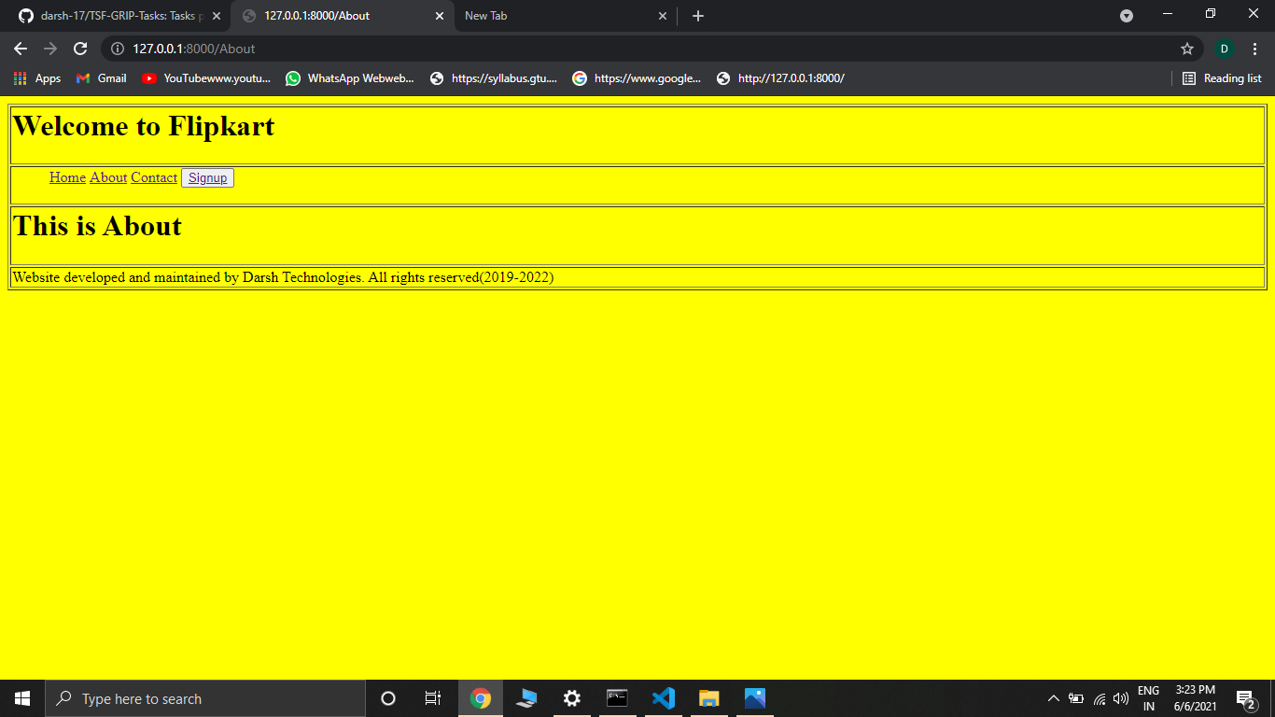

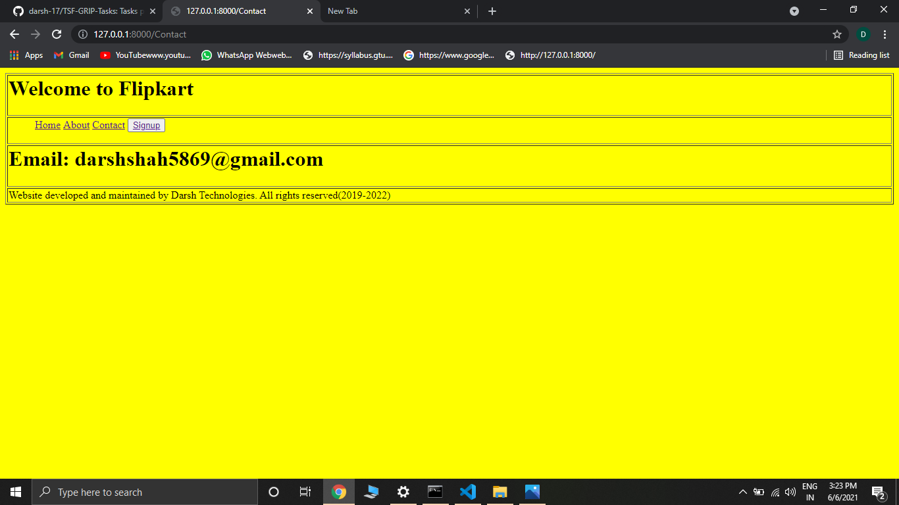

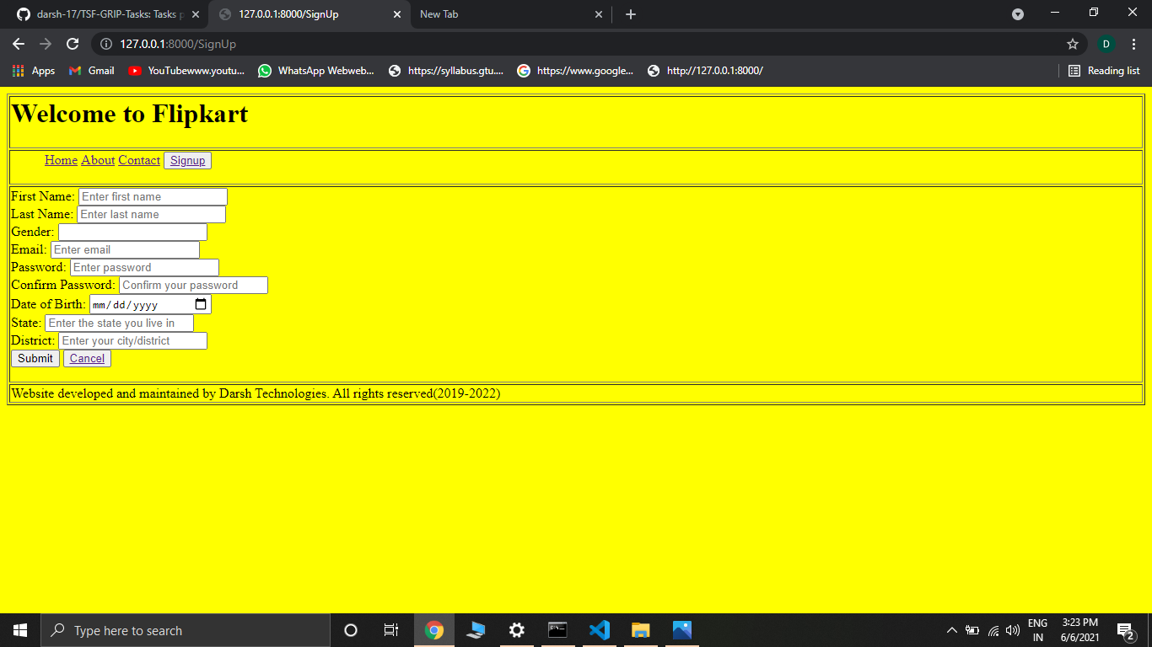

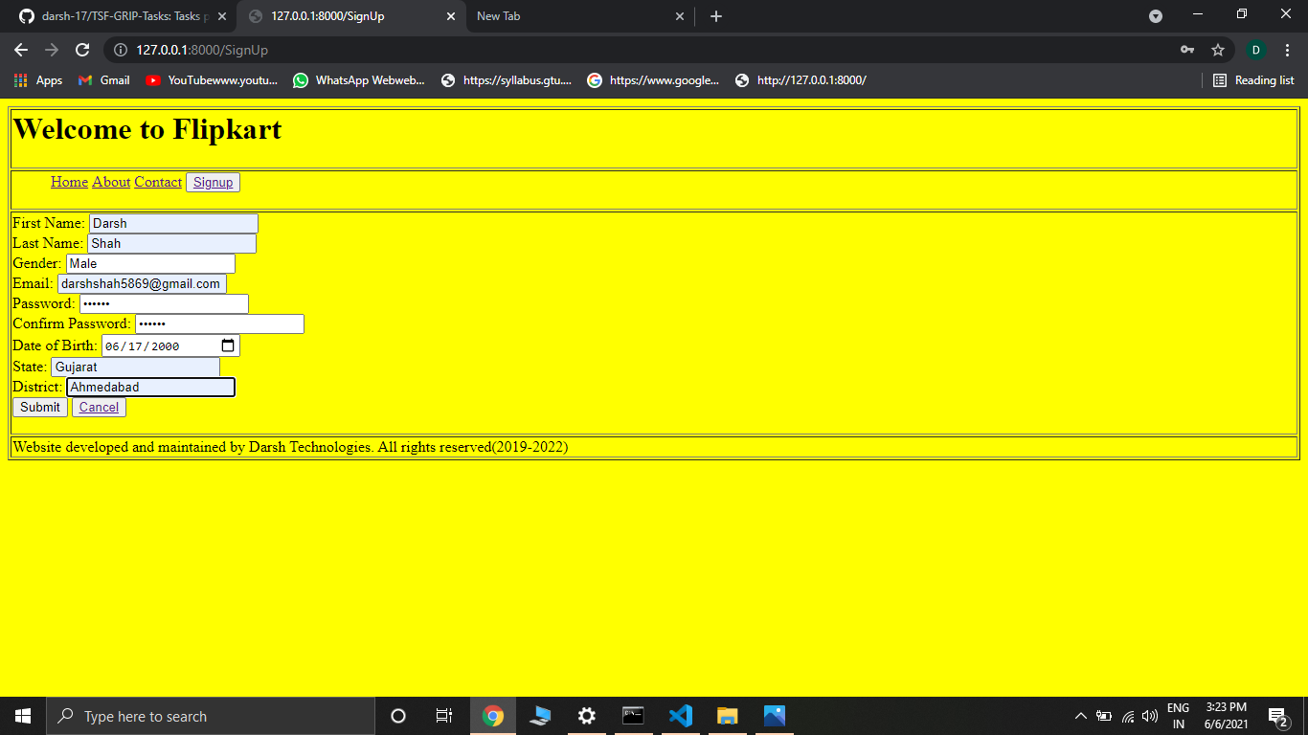

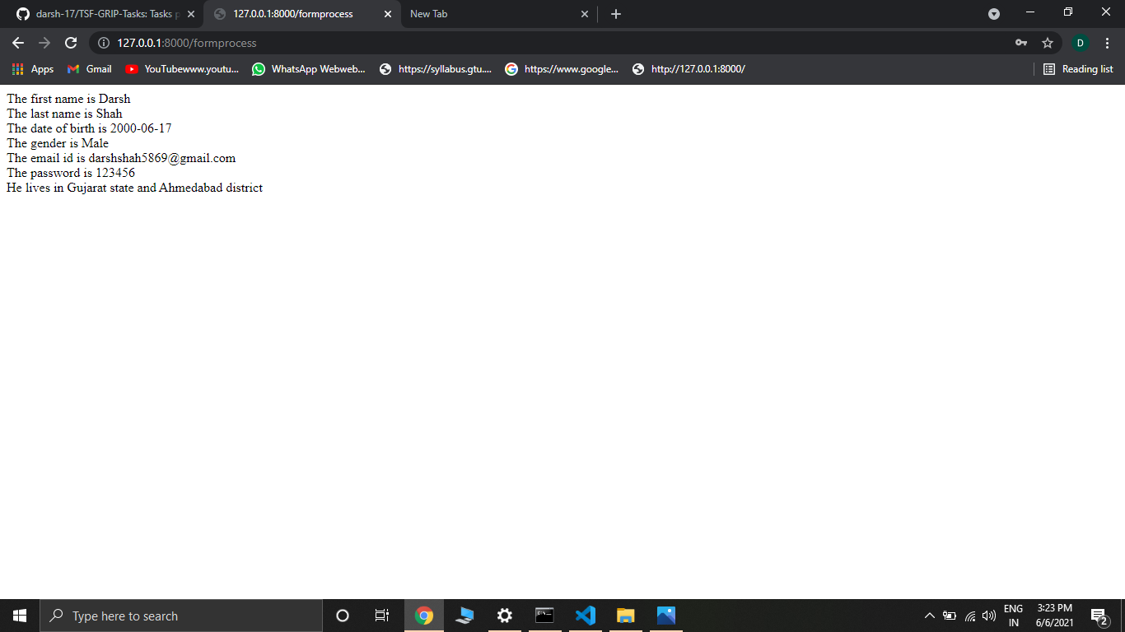

Day-12: Today was the last day of our website where we were taught the main element of Web Development that is Database Connection. We were first informed about which all databases we can use and then sir started the session about Django’s default database engine that is sqlite3.

Task: To make a simple website with DataBase connection. As I was very much interested in learning Django while reaching here, I have prepared a simple website having a register, login and logout form. I have learned some of the concepts required to build it from these lectures and rest from other YouTube channels.

Project Title: A simple single page travel website the template of which I have downloaded from the internet. It has a destination section which is connected to the database. Everytime I add the destination name, image, price and other features in the website it automatically displays it on the website. It also has a register form whose data is stored in the database when registration is complete. The login form uses Django’s inbuilt authentication feature to check the credentials. Similarly it has a logout form too. The DataBase that I have used is PostGreSQL and I have used pgAdmin4 for UI support. I am attaching the screenshots of the main files here. You can see the entire project in my GitHub repository named add2.zip.

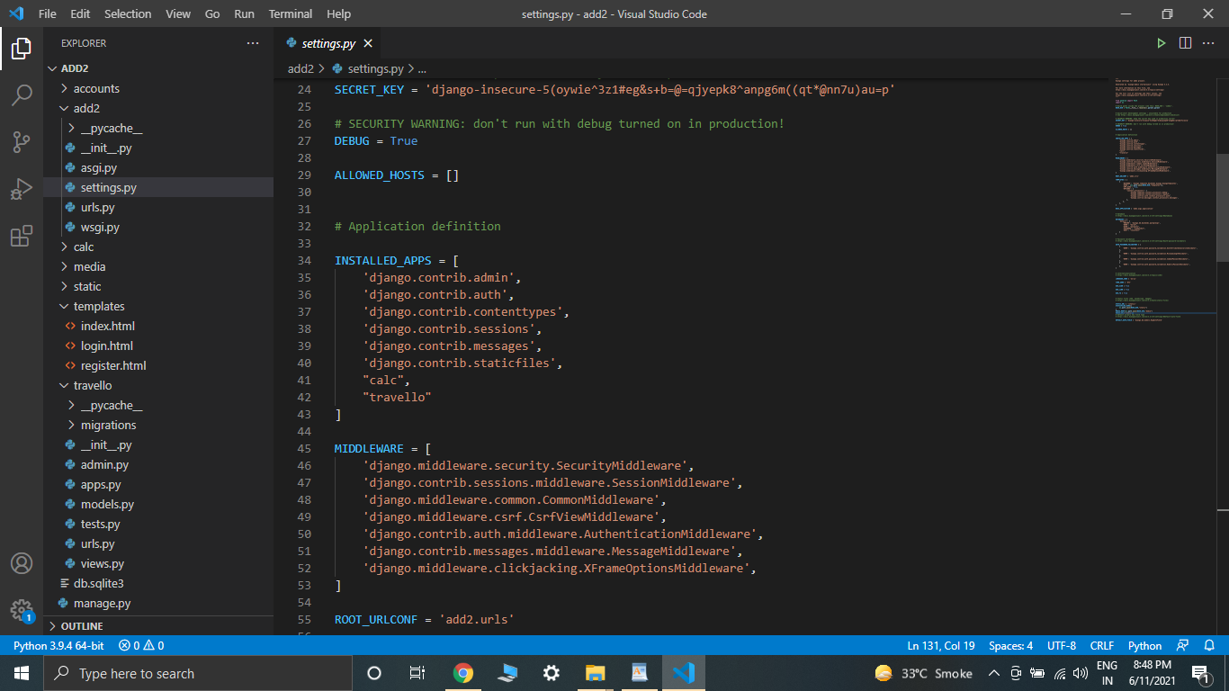

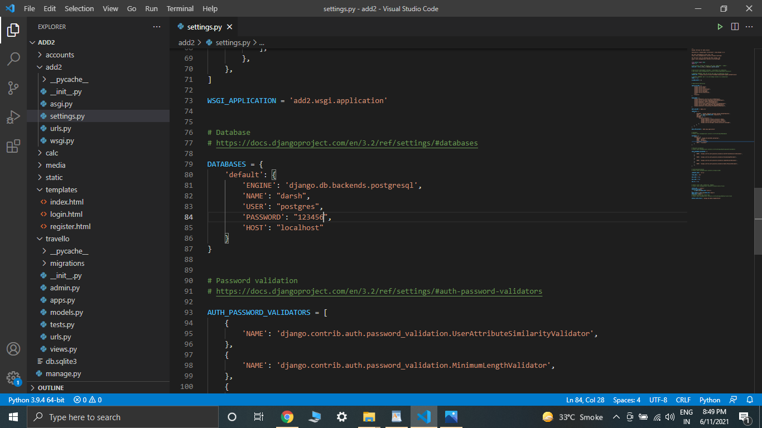

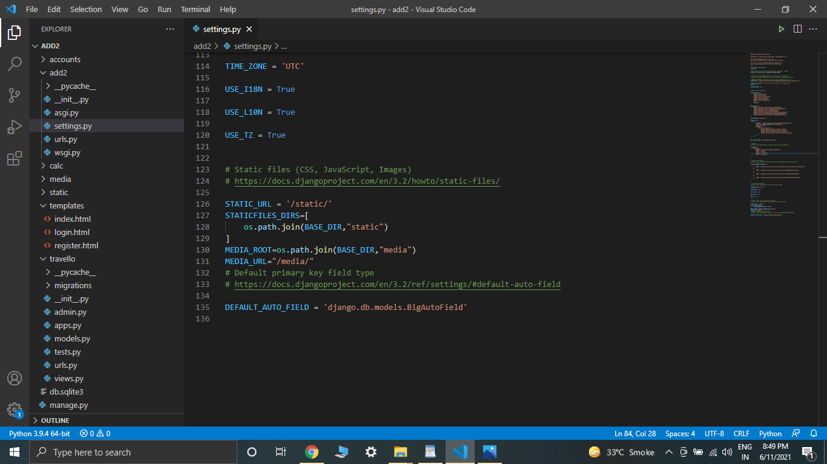

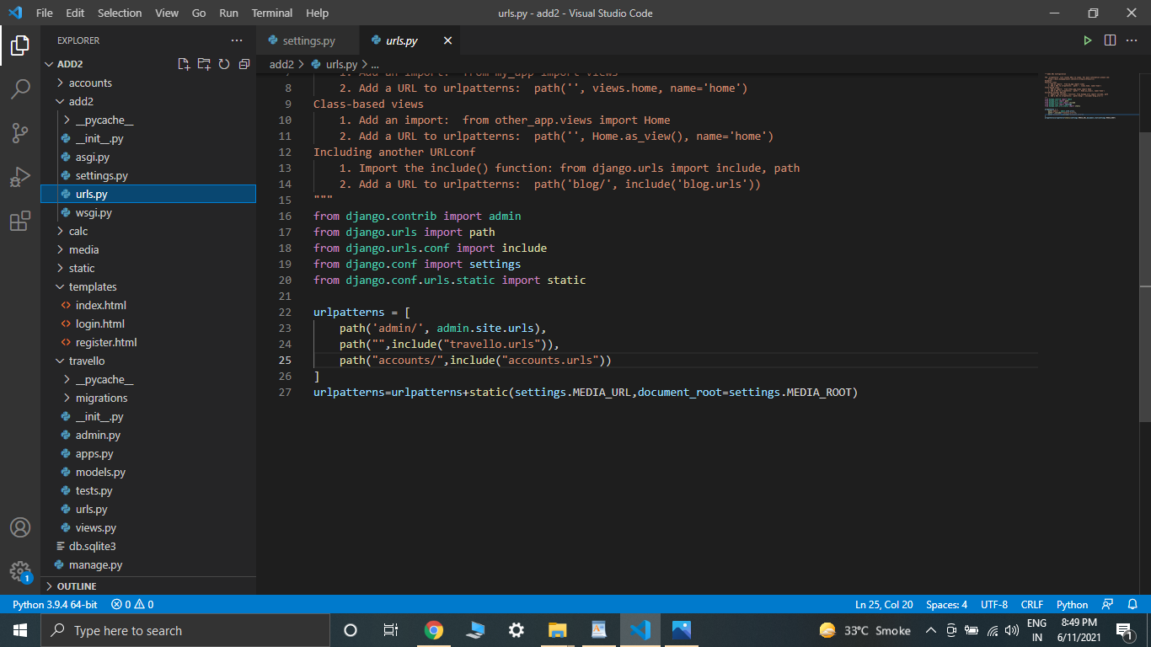

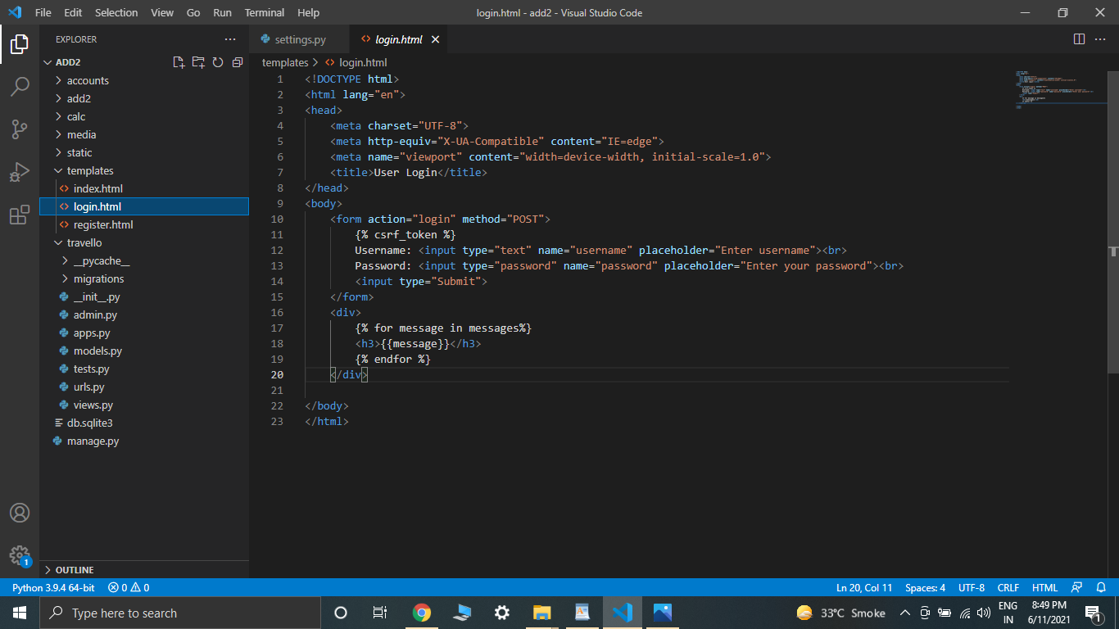

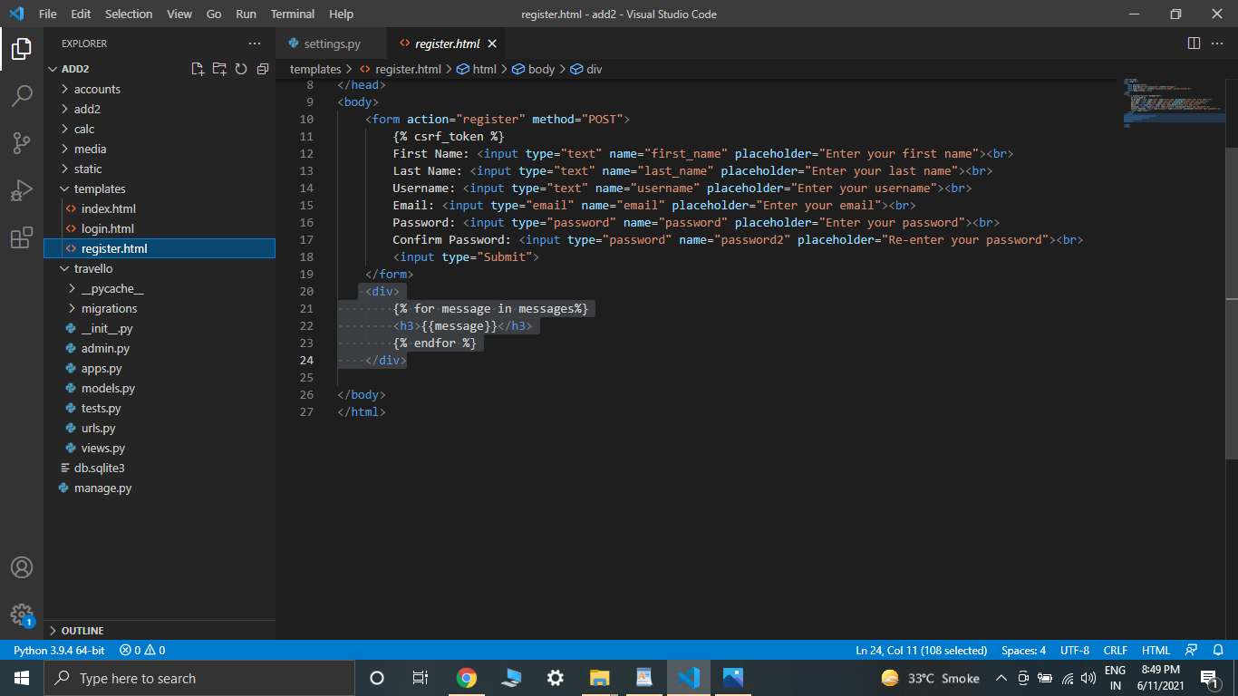

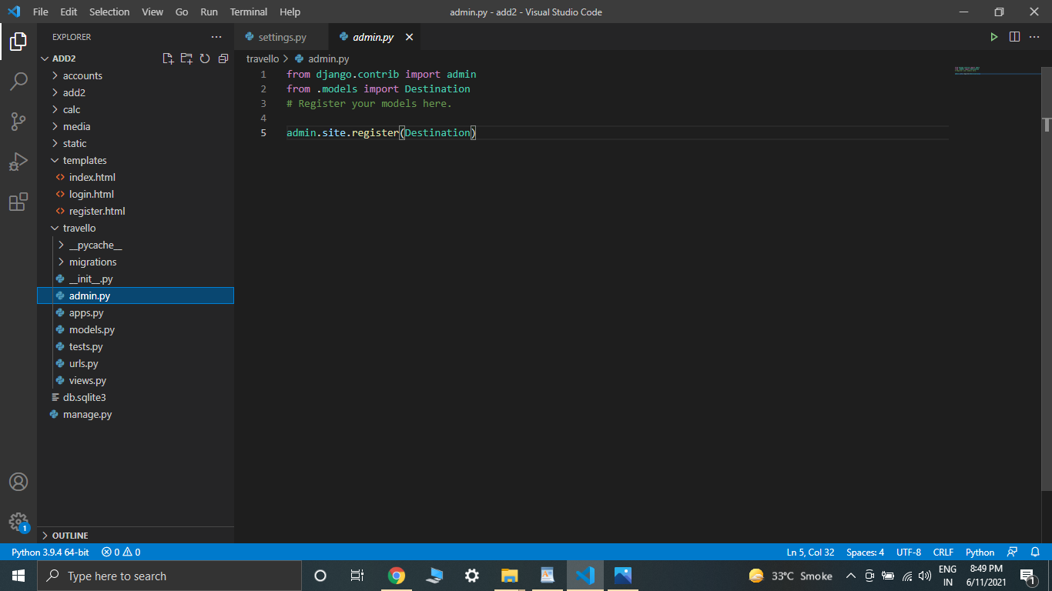

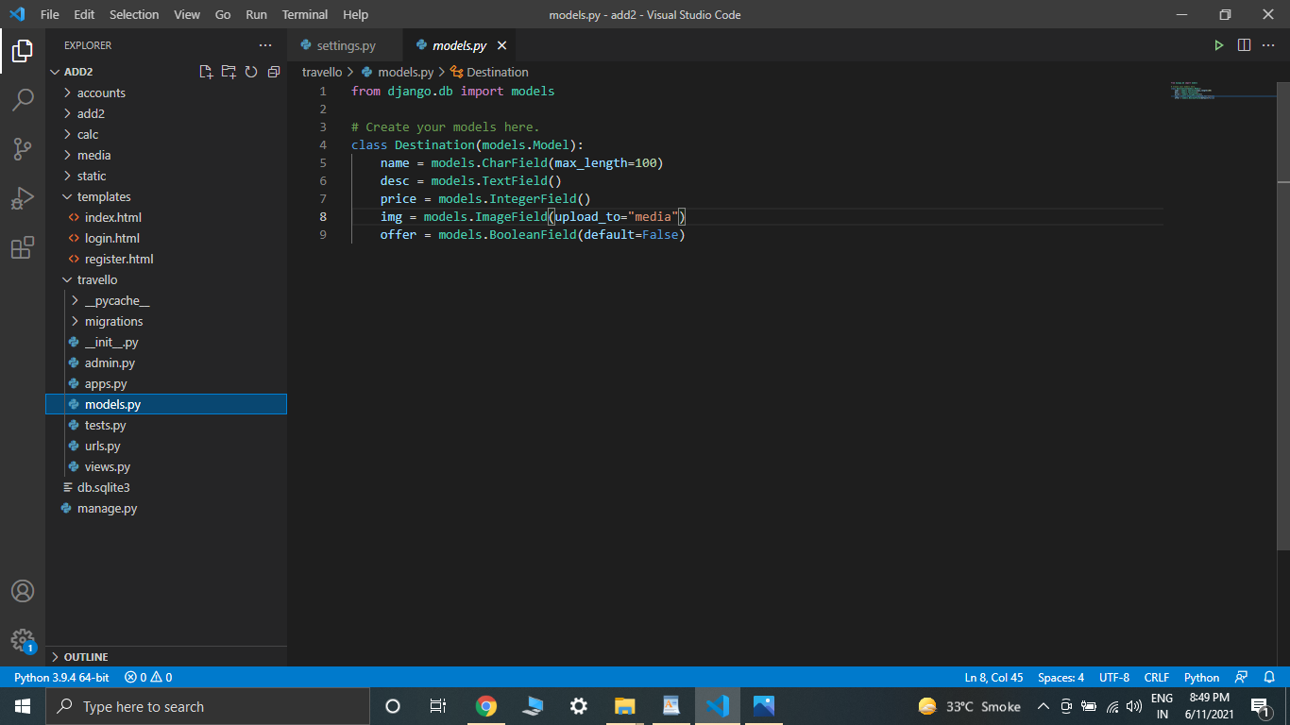

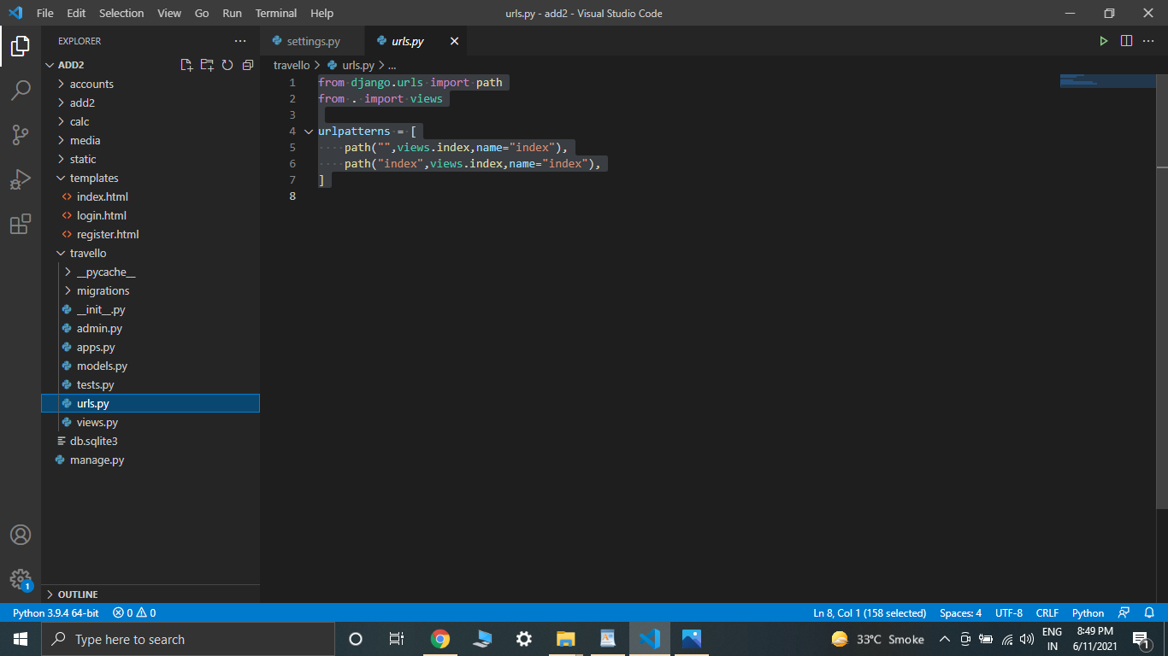

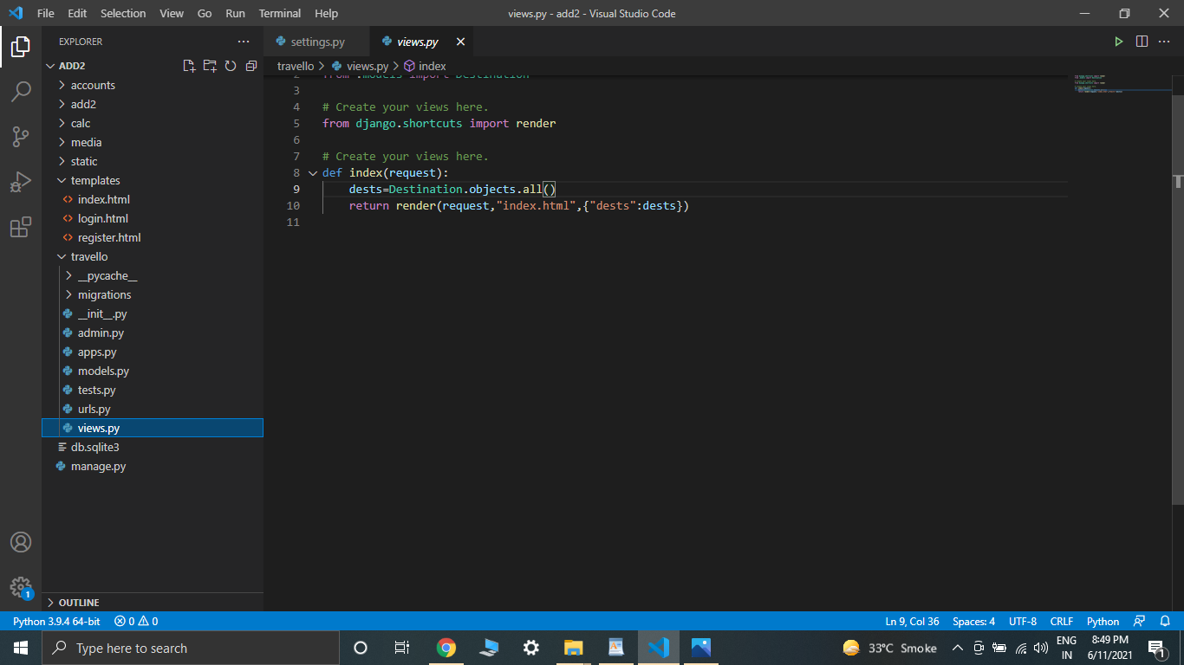

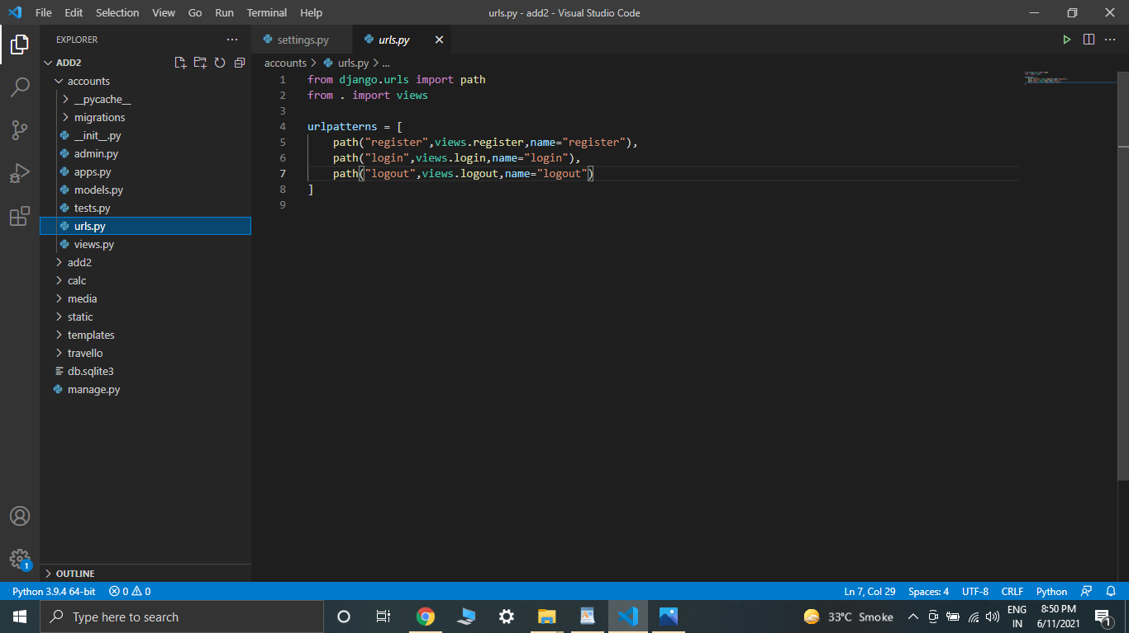

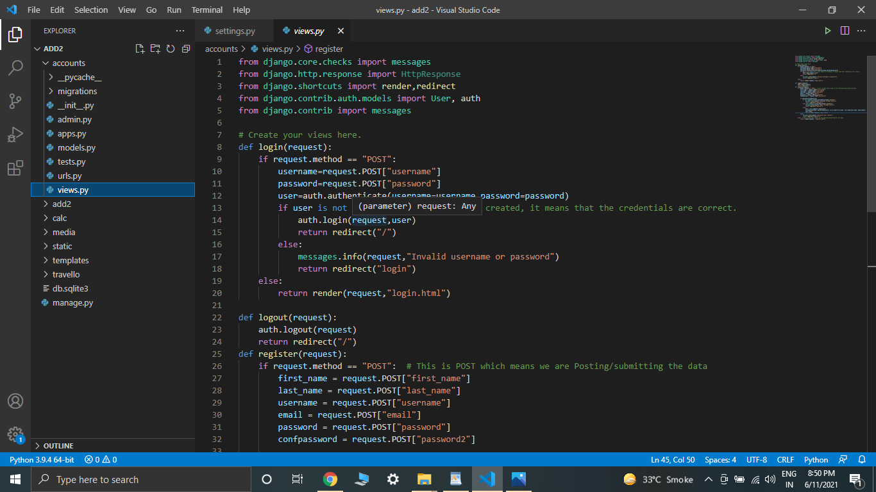

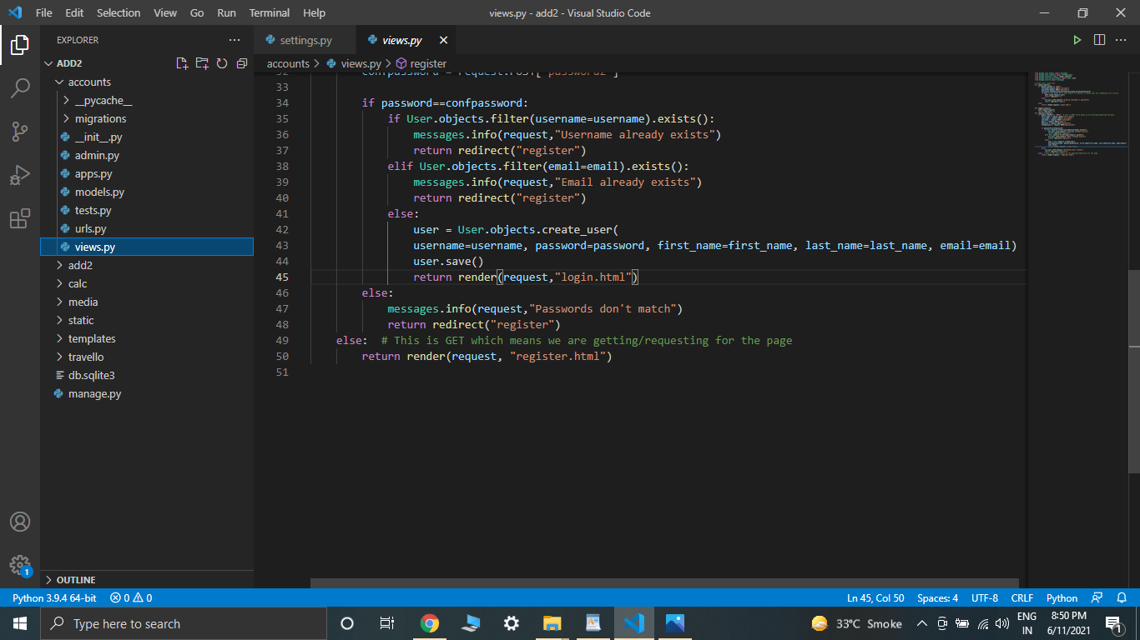

Output:

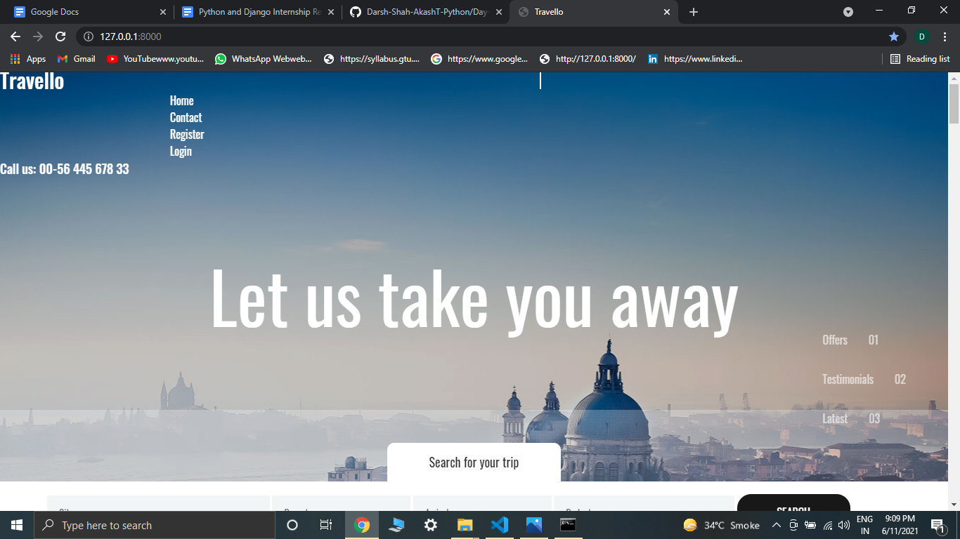

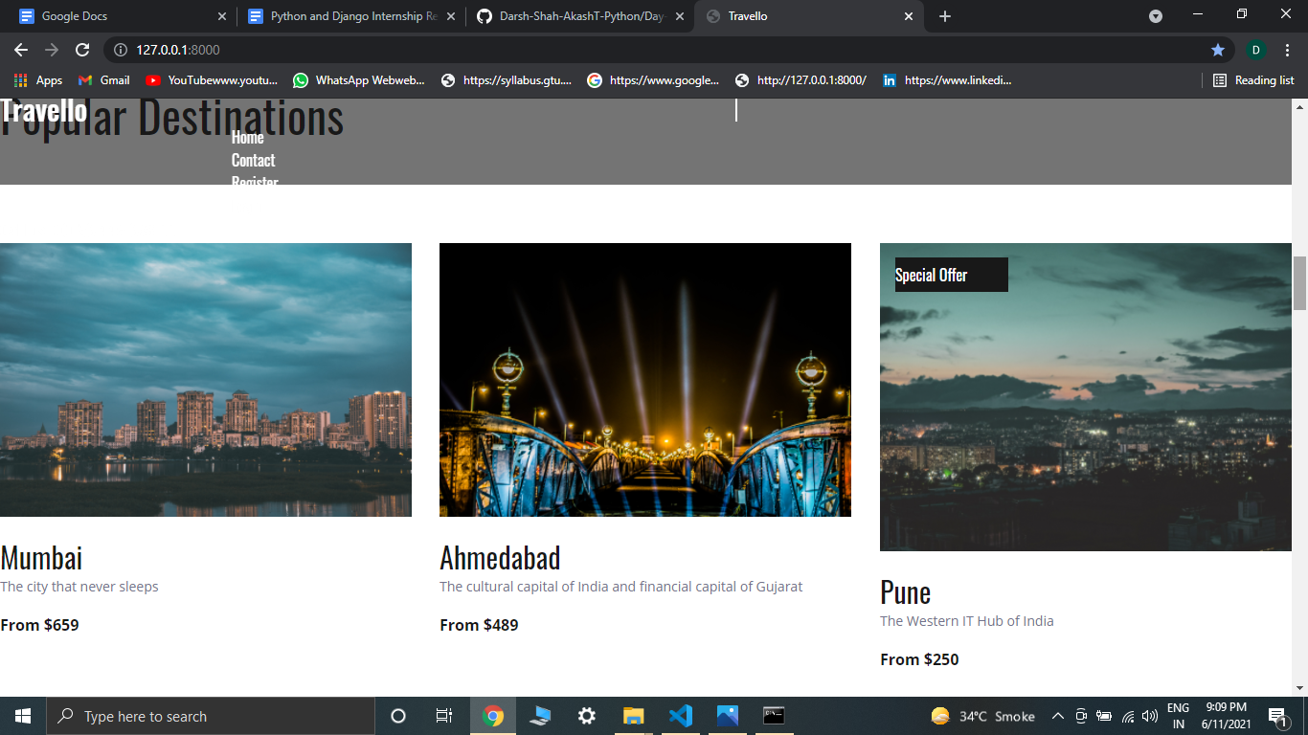

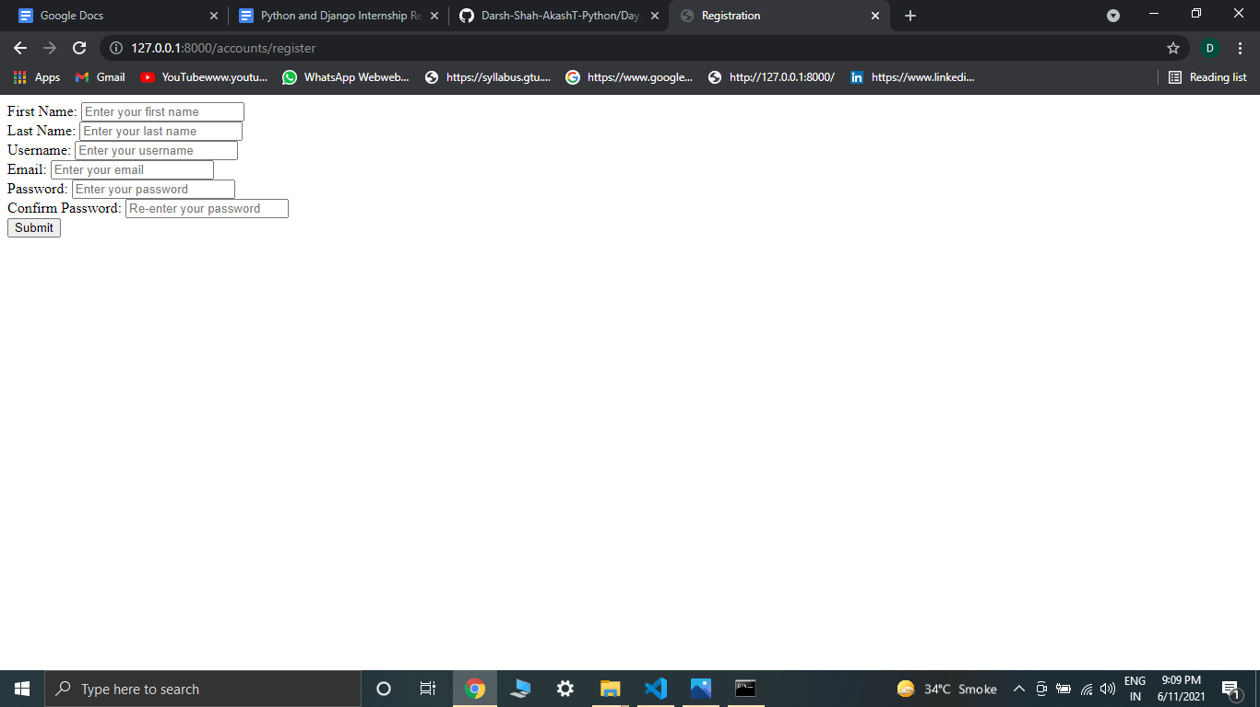

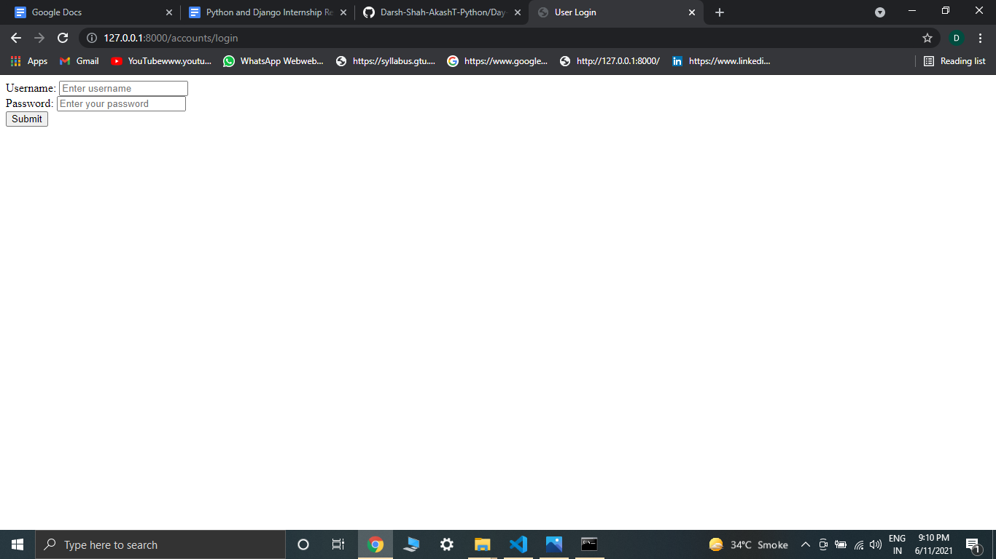

Following are the screenshots of my DataBase:

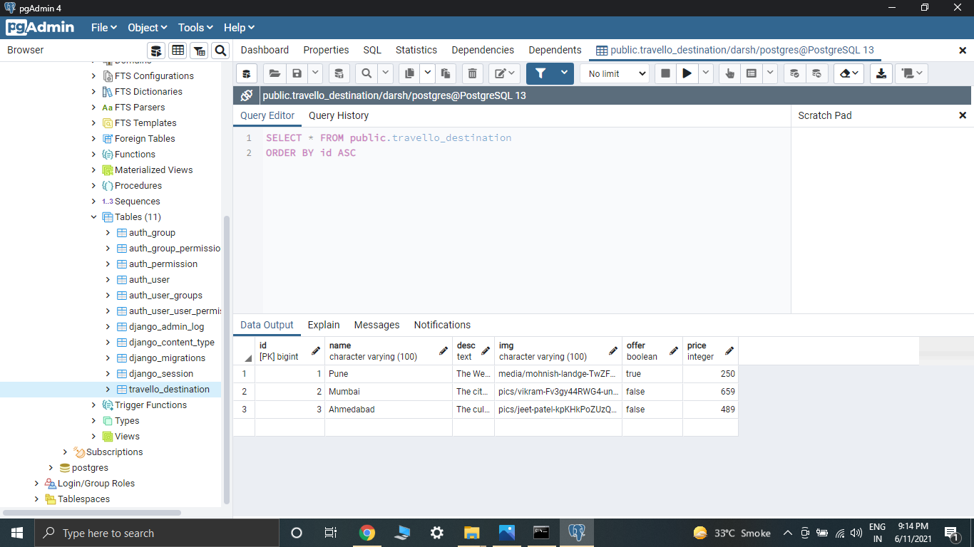

Here we can see that my destination table has 3 records and the same is reflected in my website. Here if I add one more record with required fields that it will be automatically added to my website.

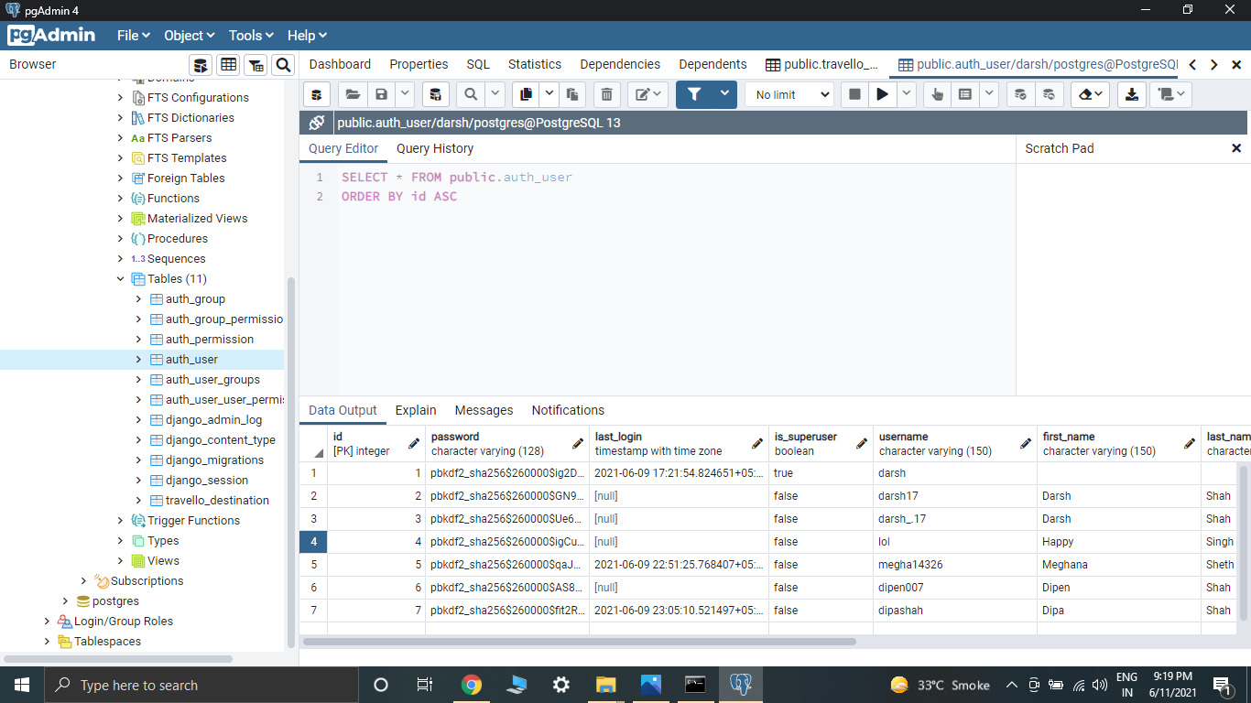

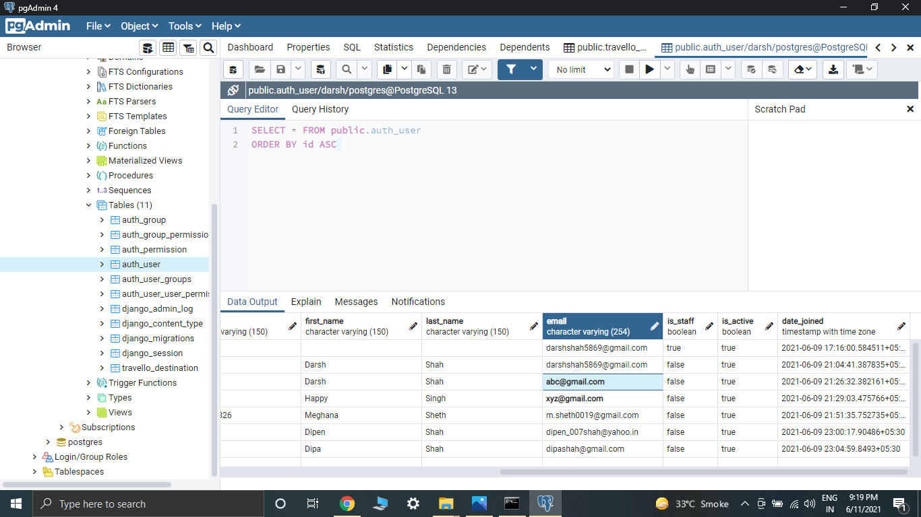

This shows my user database. I have used the built user database that is provided by Django. It will authorize login only if the data entered matches this data.